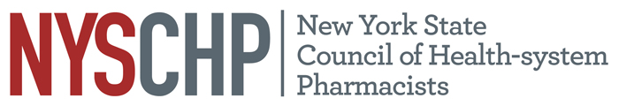
230 Washington Ave Extension, Albany NY 12203 - 518-456-8819

To: Delegates and Alternate Delegates
2019 House of Delegates

From: Liz Shlom
Chair, House of Delegates

Subject: First House of Delegates Mailing

The Rules and Regulations of the House of Delegates require all proposed amendments to the Constitution and Bylaws be mailed to the delegates and alternate delegates sixty (60) days in advance of the meeting. Please find the following posted on this website:

- 2019 Roster of Delegates
- Delegate Registration Form
- Minutes of the 2018 House of Delegates
- Notice of Open Hearing (3/21/19)
- Notice of Resolutions Committee Conference Call (4/1/19)
- NYSCHP Constitution and Bylaws – Draft Revisions
- Regulations of the House of Delegates – Draft Revisions

To complete the delegate kit, a second mailing will be sent by March 11, 2019, thirty (30) days in advance of the meeting as required by the Bylaws.

Enclosures

cc: Local Chapter President
Active Past Presidents
Board of Directors

