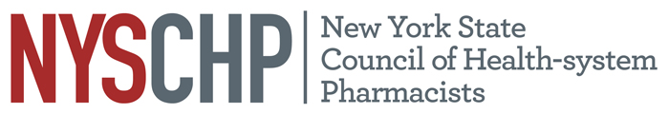
230 Washington Ave Extension, Albany NY 12203 - 518-456-8819

2019 HOUSE OF DELEGATES

April 11, 2019

Delegate Registration Form

Please check one of the following:
1. I will be registering for the Full Program of the 2019 Annual Assembly.
2. I will not be registering for the Full Program of the 2019 Annual Assembly.

CHAPTER NAME:__________________________________________________________
DELEGATE NAME:__________________________________________________________

Please return this form to NYSCHP
Attn: Rebecca Harrington: office@nyschp.org

March 11, 2019

