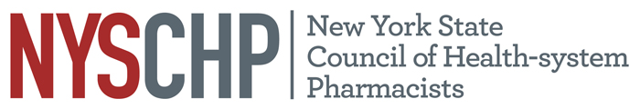
230 Washington Ave Extension, Albany NY 12203 - 518-456-8819

2019 House of Delegates
AGENDA

Order of Business
First Session April 11th, 2019 1:00 PM – 4:00 PM

- Call to Order
- Greetings
- Roll call of the delegates
- Minutes of the previous meeting
- Preliminary Report of the Committee on Resolutions
- Report of the Committee on Nominations
- Report of the Vice President, Public Policy
- Report of the Executive Director
- Report of the Treasurer
- Report of the Director, Chapter Services
- Report of the Director, Education and Workforce Management
- Report of the Director, Pharmacy Practice
- Report of the Director, Pharmacy Management
- Report of the Director, Industry Affairs
- Report of the Director, Communication Services
- Recommendations of the Delegates
- Break
- Report of the Committee on Resolutions
- Recommendations of the Delegates
- Election of Officers
- Unfinished Business
- New Business
- Announcements
- Adjournment

