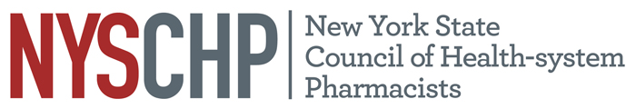
230 Washington Ave Extension, Albany NY 12203 - 518-456-8819

TO: Delegates, Alternate Delegates and Past Presidents
2018 House of Delegates
FROM: Marcia Gutfeld
Chair, House of Delegates
SUBJECT: Notice of Resolutions Committee Conference Call

The Resolutions Committee will meet via conference call on April 9, 2018 at 12 pm. To participate in this conference call, (712) 770-4700 and use Access Code: 533314. This conference call will take the place of the traditional face to face meeting prior to the NYSCHP Open Hearing and 1st Session of the NYSCHP House of Delegates.
The Committee on Resolutions shall consist of a Chairperson and one representative from each Affiliated Chapter. The Committee shall be responsible for drafting statements in resolution form which shall reflect the official policy of the Council and for reviewing resolutions submitted to it from the Affiliated Chapters and from individual members of the Council. The report of the Committee on Resolutions shall be presented to the House of Delegates.
If you have any questions, please feel free to contact the Council Office at (518) 456-8819.
Thank you.

*Please Note: Pagers, cell phones and any other electronic devices which may interrupt the House must be in the OFF position.*

