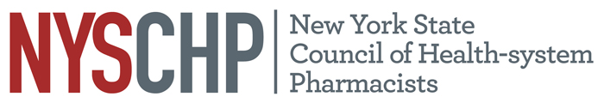
230 Washington Ave Extension, Albany NY 12203 - 518-456-8819

2018 HOUSE OF DELEGATES

April 20, 2018

Delegate Registration Form

Please check one of the following:
1. I will be registering for the Full Program of the 2018 Annual Assembly.
2. I will not be registering for the Full Program of the 2018 Annual Assembly.

CHAPTER NAME:__________________________________________________________
DELEGATE NAME:__________________________________________________________

Please return this form to NYSCHP
Attn: Joelle Carroll: office@nyschp.org

March 15, 2017

