The New York State Council of Health-system Pharmacists
210 Washington Avenue Extension, Albany, NY 12203 - (518) 456-8819 - Fax: (518) 456-9319

New York State Council of Health-system Pharmacists BOD Meeting / HOD (2018)

March 16, 2018

Board of Directors Report

Chapter Services
William Allan Prescott, Jr., PharmD

RESPONSIBILITY OF THE DIVISION

The charge of the Division of Chapter Services, as defined in the Constitution and Bylaws of the New York State Council of Health-system Pharmacists (NYSCHP), is to coordinate the issues and information between the Board of Directors and the Membership through the affiliated chapters. This division is also responsible for the coordination of activities with Schools of Pharmacy.

COMMITTEES OF THE DIVISION

Membership Committee

- Purpose: To promote membership growth for the NYSCHP by recommending and implementing recruitment and retention activities.

- Committee Composition (2017-18):

Position | Chapter / Org. | Member | Email
Chair | Rochester | Matthew Zak | mzak@sjfc.edu
Member | Central | Matthew Taranto | Matthew.Taranto@sjhsyr.org
Member | Long Island | Caesar Alaienia | Caesar.Alaienia@stonybrookmedicine.edu
Member | New York City | Zane Last | rxlast@gmail.com
Member | Northeastern | Leslie Riddle | Leslie.Riddle@sphp.com
Member | Rochester | Chris Dailey | Christopher.Dailey@thompsonhealth.org
Member | Royals | Lauren Healey | Lhealy@northwell.edu
Member | Southern Tier | Jibi Philip | Jibi.Philip@guthrie.org
Member | Westchester | Grace Shyh | gis9029@nyp.org
Member | Western | Tim Hutcherson | hutchert@dyc.edu
Member | NYSCHP BOD | William Prescott | prescott@buffalo.edu
New Practitioner | Northeastern | Mara Garfinkel | Mara.Garfinkel@acphs.edu
Student | UB SPPS | Rachael Cardinal | rmcardin@buffalo.edu
Email distribution list: Caesar.Alaienia@stonybrookmedicine.edu; rxlast@gmail.com; Leslie.Riddle@sphp.com; mzak@sjfc.edu; gis9029@nyp.org; Matthew.Taranto@sjhsyr.org; Mara.Garfinkel@acphs.edu; jpinto@CHPNET.ORG; SSeyse@KaleidaHealth.Org; sflynn@nyschp.org; Lhealy@northwell.edu; Christopher.Dailey@thompsonhealth.org; hutchert@dyc.edu; Jibi.Philip@guthrie.org; rmcardin@buffalo.edu

- Meeting Schedule:
  - Meeting #1: September 6, 2017 @ 12:00-1:00 EST
  - Meeting #2: November 7, 2017 @ 12:00-1:00 EST
  - Meeting #3: January 23, 2018 @ 12:00-1:00 EST
  - Meeting #4: March 6, 2018 @ 12:00-1:00 EST

- Status of Objectives:
  - Strategic Plan, Strategy: Strengthen value proposition of NYSCHP membership through effective programs, services and initiatives to all NYS health-system pharmacists. Know and meet member needs:
    - Membership survey: Completed summer/fall 2015. Data used for 2016-17 strategic planning. Plan to repeat survey in 5 years (summer/fall 2020).
  - Track / Analyze Membership Statistics:
    - Current membership data – see appendix
  - Facilitate identification of under-represented groups and geographic regions:
    - Geographic barriers of chapters: NYSCHP office and membership committee underwent a collaborative effort to establish chapter boundaries.
      - NYSCHP chapter presidents identified the counties they consider to be within their chapter: the results of this indicated that there are both double-claimed (2) and unclaimed (15) counties.
      - Council office performed a membership database is clean up, reviewed every member listed in the NYSCHP database, and provided data pertaining to the number of members in all NYS counties (including double-claimed counties and unclaimed counties).
      - Double-claimed and unclaimed counties, for which total membership was based on address ranged from 0-16 (median membership = 1), were assigned to chapters. Both double-claimed counties were previously claimed by Leatherstocking, which has since been dissolved. The adjustments to the chapter boundaries did not have a significant impact on membership and therefore little to no impact on delegate count. Map available @ http://www.nyschp.org/chapters.
      - Chapter presidents vote (8/17/17)… 5 “yea” (Central, Long Island, Rochester, Royals, Western), 0 “nay”, 1 “abstain” (NYC). Absent: Northeastern, Southern Tier, Westchester (e-vote requested: Northeastern = “yea”; Southern Tier = “yea”; Westchester = “yea”)… approved.
      - NYSCHP BOD vote (8/18/17)… approved.
    - New Chapter Start-up Funds Loan Policy
      - Each new Chapter of the NYSCHP are eligible to receive a loan amount up to $1000.00 to help support start-up efforts in establishing the new chapter. The Chapter is required to pay back the loan in kind over the course of 2-5 (two-to-five) years. Approved by NYSCHP BOD 10/23/16.
  - Strategic Plan, Strategy: Develop formal membership recruitment and retention plan – with outreach to all NYS health-system pharmacists to grow membership. Membership Recruitment/Retention Initiatives:
    - Implement incentives for chapters to expand membership (2015 HOD recommendation):
      - NYSCHP membership drive grant program: The NYSCHP has set aside $2000 for local chapter recruitment initiatives ($200 per chapter).
        - Grants awarded (2017): Rochester, Royals.
        - Grants awarded (2018): Western.
    - Pledge membership option: Implemented in May 2016. Active member dues = $225. Pledge member dues = $100 (for those who have not been members for the past three years). Revised pledge membership criteria at October 2017 BOD meeting from: “For pharmacists who would like to experience the benefits of a NYSCHP membership at a discount for their first year. It is only available to those who have not been a NYSCHP member for the past three years.” to: “For pharmacists who would like to experience the benefits of a NYSCHP membership at a discount for their first year. It is only available to those who have not been an active NYSCHP member for the past three years. Members who held resident membership during the past year are eligible for pledge membership.” Shaun to schedule an email to go out to the residency list at the end of the residency year. Membership committee supported change 9-6-17. NYSCHP BOD approved 9-25-17.
      - Action item: How are we ensuring members do not perpetually renew as pledge members? Council office (SF) has addressed this issue moving forward – discussed at 3-6-18 membership committee meeting.
      - Action item: Plan to assess conversion of pledge membership to full active membership during 2018-19 year (student project, overseen by membership committee chair).
    - Institutional membership option: Membership committee signed off on the project. Approved by NYSCHP Executive Committee 10/12/16. Approved by NYSCHP BOD 10/22/16.
      - Action item: How are we handling dues reimbursement for the institutional memberships? There is a risk for over-reimbursement to chapters for those members (e.g., 40% discounted active-memberships, free resident members, free tech members). Plan to update dues reimbursement policy and bring an updated policy to the virtual HOD. Approved by NYSCHP BOD 10-12-17. Virtual HOD pending spring 2018.
    - NYSCHP “Ambassador” Program: This program serves to: (1) provide a mechanism for personal connection between the NYSCHP and its local chapters with new members so as to create a sense of belonging; and, (2) identify “individual” member needs/wants. The ultimate purpose of this initiative is to increase active involvement and retention of members. Approved by membership committee 9/20/16. Approved by NYSCHP BOD 10/22/16. Emailed to chapter presidents 10/31/16. Encouraged chapter presidents to implement at 2017 Annual Assembly.
      - Action item: Work with NYSCHP office to add wants/needs-based questions to membership join/renewal form.
    - Membership recruitment tool / guide – Considering development of a member recruitment tool / guide for chapter leaders.
      - Action item: Membership committee to discuss at 3/6/2018 meeting.

  - Strengthening the relationship between the Council and the Chapters: Communication identified as a key area for improvement in order to facilitate this goal… alignment of Council | Chapters. Discussed w/ Chapter Presidents at 10-13-17 BOD meeting.
    - Action item: Membership committee charge in 2018-19.

School of Pharmacy (SOP) Faculty Liaison Committee

- Purpose: To promote and encourage involvement in NYSCHP to faculty and future pharmacists.

- Committee Composition (2017-18):
Position | School/Org. | Member | Email
Chair | NYSCHP BOD | William Prescott | prescott@buffalo.edu
Member | Albany | Nicole Stack Lodise | Nicole.Stack@acphs.edu
Member | Binghamton | TBD | TBD
Member | D’Youville | Tim Hutcherson | hutchert@dyc.edu
Member | LIU | Maria Sorbera | maria.sorbera@liu.edu
Member | St. John Fisher | Matthew Zak | mzak@sjfc.edu
Member | St. John’s | Joseph Brocavich | brocavij@stjohns.edu
Member | SUNY Buffalo | Nicole Cieri-Hutcherson | necieri@yahoo.com
Member | Touro | Andrew Smith  Amy Wang | andrew.smith25@touro.edu  zhe.wang6@touroc.onmicrosoft.com
Student | NYSCHP BOD | Stephanie Lombardi | Stephanie.Lombardi@acphs.edu
Student | Albany | Victoria Ostrovskiy | Victoria.Ostrovskiy@acphs.edu
Student | Binghamton | TBD | TBD
Student | D’Youville | Natalia Dziadosz | dziadn09@dyc.edu
Student | LIU | Eva Paige Morgan | eva.morgan@my.liu.edu​
Student | St. John Fisher | Jordan Siembor | jms05473@sjfc.edu
Student | St. John’s | Michael Lau | michael.lau13@stjohns.edu
Student | SUNY Buffalo | Courtney Skriptshak | caskript@buffalo.edu
Student | Touro | TBD | TBD
Email distribution list (liaison): Nicole.Stack@acphs.edu; maria.sorbera@liu.edu; mzak@sjfc.edu; brocavij@stjohns.edu; necieri@buffalo.edu; gormane@dyc.edu; hutchert@dyc.edu; andrew.smith25@touro.edu; zhe.wang6@touroc.onmicrosoft.com
Email distribution list (student): Stephanie.Lombardi@acphs.edu; Victoria.Ostrovskiy@acphs.edu; dziadn09@dyc.edu; eva.morgan@my.liu.edu​; jms05473@sjfc.edu; caskript@buffalo.edu; michael.lau13@stjohns.edu

- Meeting Schedule:
  - Meeting #1: September 5, 2017 @ 12:00-1:00 EST
  - Meeting #2: November 8, 2017 @ 12:00-1:00 EST
  - Meeting #3: January 24, 2018 @ 12:00-1:00 EST

- Status of Objectives:
  - Increase student engagement in the NYSCHP:
    - Created a NYSCHP Student Committee to better connect the NYSCHP BOD with students within the NYS Schools of Pharmacy to: (1) increase student membership in the NYSCHP; (2) actively engage student members in Council activities; (3) groom future NYSCHP leadership; (4) enhance the benefits of student membership (e.g., develop student-focused programming at the Annual Assembly). NYSCHP BOD approved creation of this committee on 7/11/16.
    - Added student membership to the NYSCHP BOD and all NYSCHP committees: The NYSCHP BOD approved the addition of a student member to: (1) the NYSCHP BOD; and (2) the following NYSCHP committees: Membership, AA, Professional Affairs, Public Policy, Public Relations, and Technician on 7/11/16, and C&B and New Practitioners on 7/14/17 – approved.
  - Assist in the tracking / analysis of student membership: Status – ongoing.
  - NYSCHP Corporate Member Scholarship Award: Status – annual.
    - 2018: Topic – “US Opioid Epidemic / Drug Diversion: How can Pharmacists Assist in a Solution” (Due 3/9/18). Details available @ http://www.nyschp.org/students
  - Student Chapter Grant Program: Status – annual.
    - Grants awarded (2017): UB SPPS.
    - Grants awarded (2018): None to date.
  - Student involvement in the Annual Assembly:
    - AA Committee taking lead on this item.
    - Per discussions with student-leaders: (1) optimal time for Annual Assembly is early-mid April; (2) all student-years may attend; (3) cost would be student-dependent, but value important; (4) need for student-specific programming (e.g., law review, standing out as a residency candidate, interviewing tips); and (5) student-specific networking opportunities (e.g., for summer internships). Annual Assembly Committee will consider this data/feedback (in cooperation with the NYSCHP BOD) for planning of future Annual Assemblies.

Student Committee

- Purpose: To advise the NYSCHP BOD on issues of the profession that relate to students, including but not limited to opportunities to enhance/expand student membership

- Committee Composition (2017-18):
Position | Committee/Org. | School | Member | Email
Advisor | NYSCHP BOD | N/A | William Prescott | prescott@buffalo.edu
Chair | NYSCHP BOD | Albany | Stephanie Lombardi | Stephanie.Lombardi@acphs.edu
Member | NYSCHP BOD | N/A | Chris Jadoch | jadochc@dyc.edu
Member | NYSCHP BOD | N/A | Anthony Longo | Alongo@northwell.edu
Member | NYSCHP BOD | N/A | Shaun Flynn | sflynn@nyschp.org
Member | Annual Assembly | TBD | TBD | TBD
Member | CE & Prof. Dev. | UB SPPS | Christian Bernhardi | cabernha@buffalo.edu
Member | CE & Prof. Dev. | UB SPPS | Merin Panthapattu | merinpan@buffalo.edu
Member | C&B | TBD | TBD | TBD
Member | Membership | UB SPPS | Rachael Cardinal | rmcardin@buffalo.edu
Member | Prof. Affairs | TBD | TBD | TBD
Member | Prof. Development | TBD | TBD | TBD
Member | Public Policy | UB SPPS | Kelsey Violanti | kelseyvi@buffalo.edu
Member | Public Relations | UB SPPS | Kaitlyn Victor | kaitlynv@buffalo.edu
Member | Technician | TBD | TBD | TBD
Member | SOP | Albany | Victoria Ostrovskiy | Victoria.Ostrovskiy@acphs.edu
Member | SOP | Binghamton | TBD | TBD
Member | SOP | D’Youville | Natalia Dziadosz | dziadn09@dyc.edu
Member | SOP | LIU | Eva Paige Morgan | eva.morgan@my.liu.edu​
Member | SOP | SJF | Jordan Siembor | jms05473@sjfc.edu
Member | SOP | St. John’s | Michael Lau | michael.lau13@stjohns.edu
Member | SOP | SUNY Buffalo | Courtney Skriptshak | caskript@buffalo.edu
Member | SOP | Touro | TBD | TBD

- Meeting Schedule (to meet quarterly):
  - Student Committee Meeting #1: September 6, 2017 @ 2:00-3:00 EST
  - Student Committee Meeting #2: January 24, 2018 @ 2:00-3:00 EST
  - Student Committee Meeting #3: March 7, 2018 @ 2:00-3:00 EST

- Status of Objectives:
  - (1) Develop a system to ensure continuity of the committee:
    - Added a chair-elect position: revised student leadership document approved by BOD 1/27/17.
    - Plan to establish student leaders prior to end of the spring semester: Nominations to be requested during March/April (Deadline April 15) and appointments late April (Deadline April 30). Discussed at 3/23/17 SOP faculty liaison committee meeting.
    - Recommended integrating faculty liaison committee member into the SSHP C&B at each school.
    - Timeline/Calendar: Established document on a shared drive to coordinate committee deadlines and goals
    - Transition plan:
      - Incoming Chair (2017-18): Stephanie Lombardi (ACP)
      - Chair-Elect (2017-18): TBD
      - Committee positions (2017-18): In-progress
      - Standard Operating Procedure: Continuous document that all students can document what they are working on and where they leave off to help with the transition for the coming year (on shared drive).
  - (2) Identify ways to attract/retain Millennials to the NYSCHP:
    - Student committee developed a survey for SSHP members at each school to gauge needs/wants. Council office assisting with distribution of survey.
    - New Practitioners Forum (similar to ASHP): Endorsed by the SOP Faculty Liaison Committee on 3/23/17. Charged to Director of Pharmacy Management.

OTHER CHAPTER SERVICES ACTIVITIES

- Chapter President Leadership Fostering:
  - Contact Chapter Presidents as needed with important information, deadlines, upcoming action items, etc.
  - Chapter Presidents (2017-18):
Chapter | Chapter President | Email
Central | Peter Aiello | AIELLOP@upstate.edu
Long Island | Allison Raich | allisonraichrx@gmail.com
Northeastern | Courtney Caimano | courtney.caimano@acphs.edu
NYC | Karen Berger | karenberger7@gmail.com
Rochester | Lisa Nelson | Lisa_Nelson@urmc.rochester.edu
Royal Counties | Deep Patel | deepzpatel@gmail.com
Southern Tier | Bill Bacon | BBacon@ah.arnothealth.org
Westchester | Peter Grassi | petergrassi1@gmail.com
Western | Brian Kersten | bkersten@kaleidahealth.org

Email distribution list (chapter presidents 2017-18): AIELLOP@upstate.edu; allisonraichrx@gmail.com; courtney.caimano@acphs.edu; karenberger7@gmail.com; Lisa_Nelson@urmc.rochester.edu; deepzpatel@gmail.com; BBacon@ah.arnothealth.org; petergrassi1@gmail.com; bkersten@kaleidahealth.org

- Chapter Dues Reimbursement: Revised 1999 document. Approved by the HOD at the Virtual HOD on 3/21/17. Follow-up impact on financials.

- Position Statements to be reviewed for sunset

  - None

- 2017 House of Delegate Recommendations

  - Membership Committee:
    - None
  - School of Pharmacy Faculty Liaison Committee:
    - None

Respectfully submitted,

William Allan Prescott, Jr.

William Allan Prescott, Jr. Director, Chapter Services

Appendix. Membership Data

Membership Data: 2016
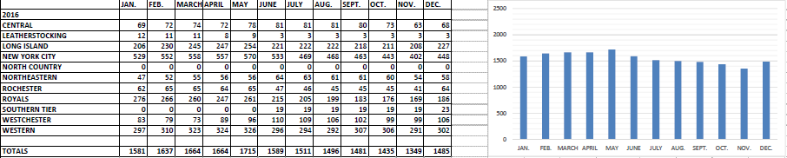

Membership Data: 2017
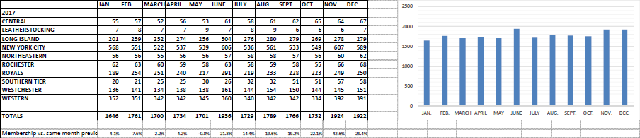

Membership Data: 2018
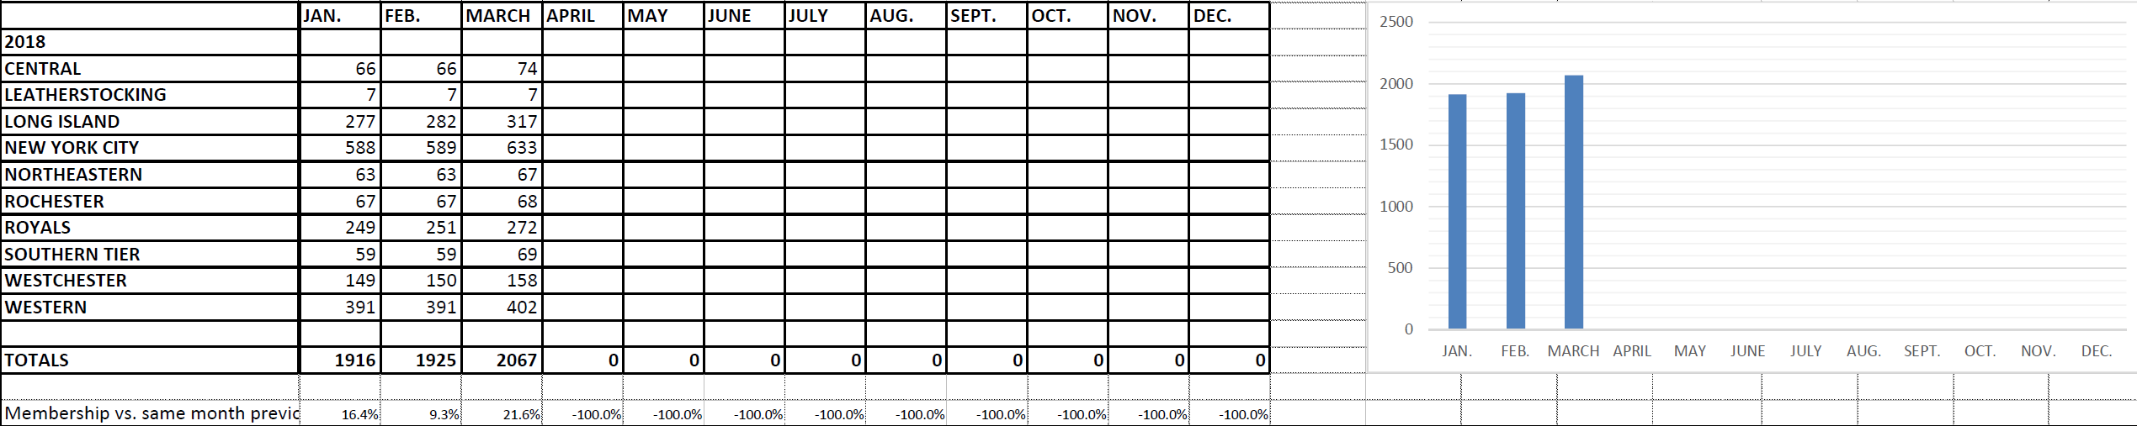
- Total:

- Active (Pharmacists, Joint, Pledge, Resident, Retired):
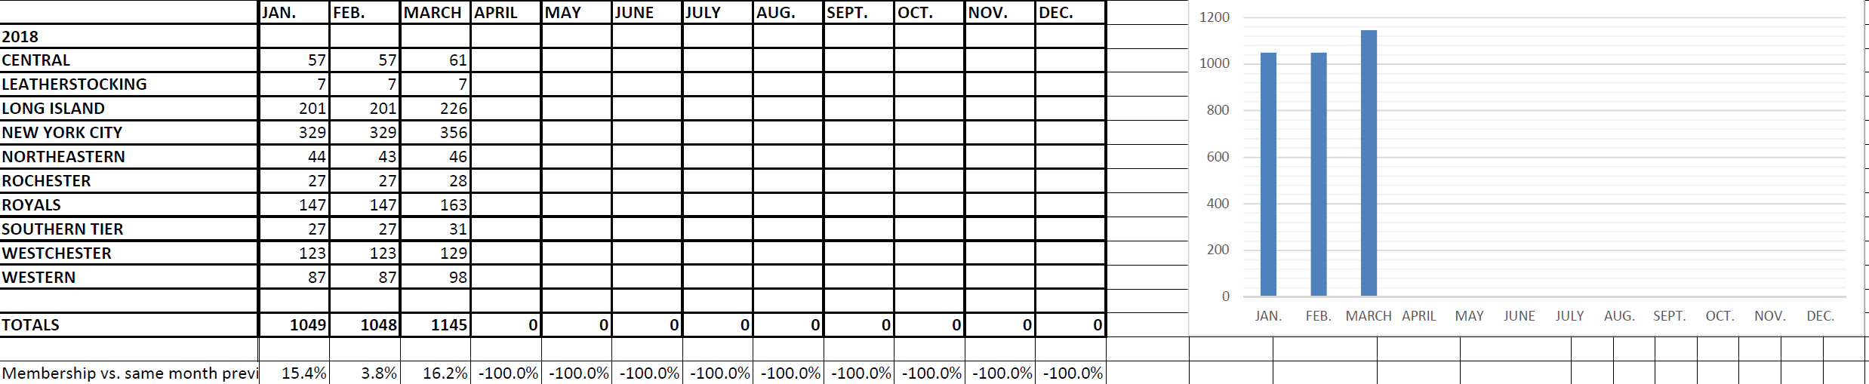

- Associate (Associate, Faculty, Student, Technician):
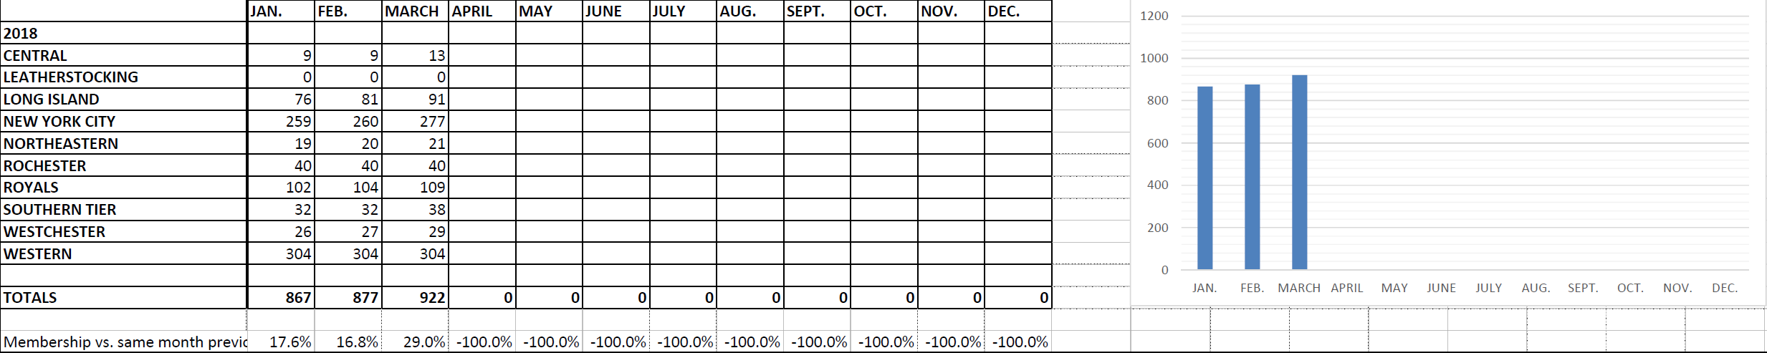

- Chapter Membership Data:
