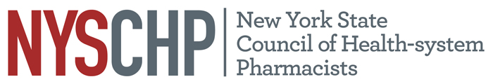

**230 Washington Ave Extension, Albany NY 12203 - 518-456-8819**

**2018 Virtual House of Delegates**

**AGENDA**

***Order of Business***

*March 15th, 2018*

*12:00 PM- 2:00 PM*

1. Call to Order

2. Greetings

3. Roll call of the delegates

4. Amendment to the chapter dues reimbursement policy

5. Position statement review

7. Unfinished Business

8. New Business

10. Announcements

11. Adjournment