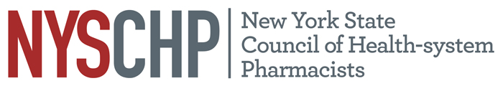
230 Washington Ave Extension, Albany NY 12203 - 518-456-8819

2020 HOUSE OF DELEGATES

April 23, 2020

Delegate Registration Form for the Annual Assembly

Please check one of the following:
1. I will be registering for the Full Program of the 2020 Annual Assembly.
2. I will not be registering for the Full Program of the 2020 Annual Assembly.

CHAPTER NAME:__________________________________________________________
DELEGATE NAME:__________________________________________________________

Please return this form to NYSCHP by March 19, 2020
Attn: Rebecca Harrington: office@nyschp.org

