Committee: New York City Chapter of Health-system Pharmacists
Topic: Formation of Diversity, Equity, and Inclusion Committees
Sponsored: Pavel Goriacko, Shanice Coriolan, Maabo Kludze, Harshal Shukla, Jennifer Bhuiyan, Toshiba Morgan-Joseph, Christine Chim, Elsen Jacob, Jamie Chin-Hon

Whereas, to meet the healthcare needs of the general population, institutions must value diversity and inclusion as central to their mission by continuously assessing, prioritizing and contributing to the formation of proactive committees that set goals and standards to champion and advocate for a more diverse and inclusive workforce,

Whereas, ASHP board of directors has approved the ASHP Task Force on Diversity, Equity, and Inclusion which makes actionable recommendations for health systems and state societies (1),

Resolved that,

New York State Council of Health-system Pharmacists encourages pharmacy institutions to form “diversity, equity, and inclusion” committees that set goals and standards to champion and advocate for a more diverse and inclusive workforce and membership.

Signed:
Pavel Goriacko | Harshal Shukla  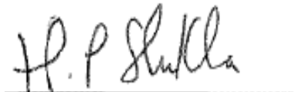 | Christine Chim
Shanice Coriolan | Jennifer Bhuiyan | Elsen Jacob
Maabo Kludze | Toshiba Morgan-Joseph  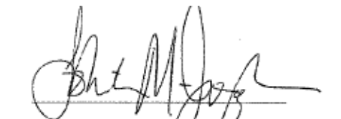 | Jamie Chin-Hon

References
- https://www.ashp.org/-/media/assets/house-delegates/docs/DEI-Task-Force-Recommendations-Revised-November-2020.ashx

