Committee: New York City Chapter of Health-system Pharmacists
Topic: Re-evaluate Hiring, Acceptance, and Promotional Practices
Sponsored: Pavel Goriacko, Shanice Coriolan, Maabo Kludze, Harshal Shukla, Jennifer Bhuiyan, Toshiba Morgan-Joseph, Christine Chim, Elsen Jacob, Jamie Chin-Hon

Whereas, increased diversity in the healthcare workforce has a large impact on addressing racial and ethnic healthcare disparities by heightening cultural awareness, improving access to healthcare for underserved patients and improving the patient experience with more effective patient-clinician communication (1, 2), and,

Whereas, the racial diversity of the pharmacist workforce does not reflect the racial diversity of the general population (3),

Resolved that,

New York State Council of Health-system Pharmacists supports frequent departmental data collection in order to evaluate candidate acceptance criteria, hiring practices, promotional criteria, salary differences, and available mentorship systems, with a goal of ensuring that these practices advance equity and diversity in the workforce.

Signed:

Pavel Goriacko | Harshal Shukla  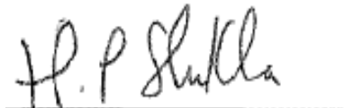 | Christine Chim
Shanice Coriolan | Jennifer Bhuiyan | Elsen Jacob
Maabo Kludze | Toshiba Morgan-Joseph  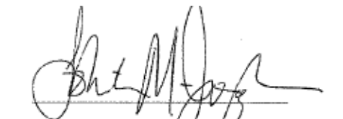 | Jamie Chin-Hon

References:
- Jackson CS, Gracia JN. Addressing Health and Health-Care Disparities: The Role of a Diverse Workforce and the Social Determinants of Health. Public Health Reports. 2014;129(1_suppl2):57-61. doi:10.1177/00333549141291S211
- Institute of Medicine (IOM). (2003). Unequal Treatment: Confronting Racial and Ethnic Disparities in Healthcare. Smedley, B. D., Stith, A. Y., Nelson A. R. eds. Washington, DC: National Academy Press.
- https://www.aacp.org/sites/default/files/2020-03/2019_NPWS_Final_Report.pdf

