Committee: New York City Chapter of Health-system Pharmacists
Topic: Incorporate Health Equity into Pharmacist and Pharmacy Technician Training Sponsored: Pavel Goriacko, Christine Chim, Maabo Kludze, Harshal Shukla, Toshiba Morgan-Joseph, Jennifer Bhuiyan, Elsen Jacob, Jamie Chin-Hon

Whereas, social determinants of health have a large influence on health outcomes, are a major cause of health disparities, and can be of a more significant contributor to health than health care services or lifestyle choices,^{1,2}

Whereas, as pharmacists are trained professionals who are relied upon to engage with vulnerable patient populations, they are uniquely positioned to impact and/or assist in reducing disparities in areas such as diabetes, asthma, and vaccine uptake to improve the health of all Americans,

Whereas, the existing level of training in health equity is largely limited to didactic lectures in cultural competency, and no specific requirements for health equity training exist in the accreditation standards for pharmacy schools and residency programs,^{3,4}

Resolved that,

The New York State Council of Health-system Pharmacists supports the incorporation of health equity domains into pharmacy school curricula, pharmacy technician programs, residency training programs, board certification competencies, professional pharmacy organizations, health-system employment, and continuing education programming to increase awareness of health disparities and enable pharmacists and pharmacy technicians to advance health equity.

Date: February 18, 2021

Signed:

Pavel Goriacko | Harshal Shukla  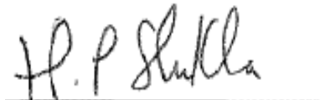 | Elsen Jacob
Christine Chim | Toshiba Morgan-Joseph  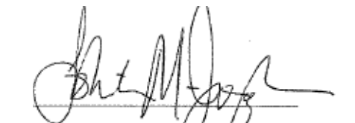
Maabo Kludze | Jennifer Bhuiyan | Jamie Chin-Hon

References:
- https://www.who.int/health-topics/social-determinants-of-health#tab=tab_1
- https://www.ashp.org/-/media/assets/policy-guidelines/docs/statements/racial-and-ethnic-disparities-in-health-care.ashx
- Olihe N. Okoro, Folakemi T. Odedina, Romonia R. Reams, W. Thomas Smith. Clinical Cultural Competency and Knowledge of Health Disparities Among Pharmacy Students. American Journal of Pharmaceutical Education Apr 2012, 76 (3) 40.
- https://www.ajpe.org/content/84/11/8418

