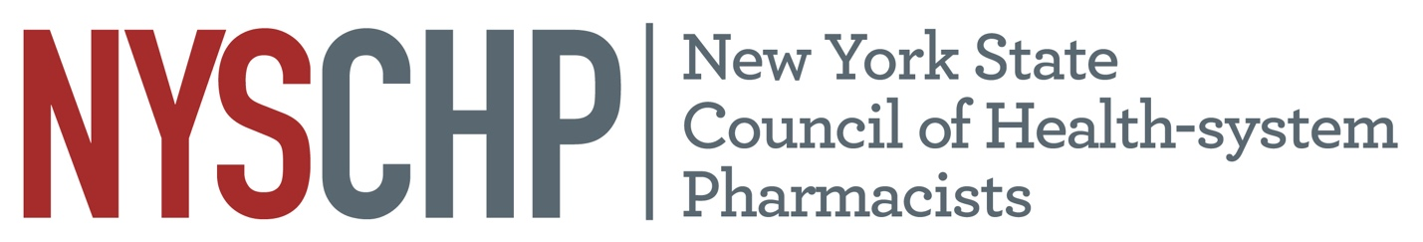

New York State Council of Health-system Pharmacists

REPORT OF Communications Committee

Angela Cheng-Lai, PharmD, BCPS

April 2021
New York

- Responsibility of the Division

The charge of the Division of Communication Services, as defined in the Constitution and Bylaws of the NYSCHP, is to be responsible for:
- Promotion of the Council on state and national levels
- Supervision of all Council publications and public relations media

- Committees of the Division

Newsletter Sub-Committee

Members: Angela Cheng, Charnicia Huggins, Ben Jacobson, Frank Palmieri, Kimberly Ng, Rubiya Kabir

Activities: Gather topics and information for articles; solicit authors for articles; proofread content for accuracy and grammatical correctness; publish newsletter on a bi-monthly basis

Activities: Future: Continue to expand the readership of our newsletter; continue to expand on the diversity of topics covered and authors invited

Podcast Sub-Committee

Members: Angela Cheng, Krishna Daiya, Emily Messing, Teresa Regis, Toshiba Morgan-Joseph, Victor Chen, Jay A. Delisle

Activities: Gather topics and information for podcast episodes; verify accuracy of content from podcast episodes, create podcast episodes to highlight various committees and accomplishments of NYSCHP members; 19 episodes (with 2,185 downloads) have been released so far

Activities: Continue to expand on the variety of topics covered, strive to cover current topics (i.e., well-being and healthcare disparities); invite a great diversity of speakers (including pharmacy technicians and other healthcare providers such as physicians and nurses)

Video Sub-Committee

Members: Angela Cheng, Krishna Daiya, Emily Messing, Tinnie Liao-Ng Yan

Activities: Gather topics and information for videos, verify accuracy of content of videos, create videos to highlight the role of pharmacists in the healthcare team, create videos to educate the public regarding health-related topics. Four videos are on our channel so far (Topics of these videos include immunization, CDTM, vaccine updates and the roles of pharmacists)

Activities: Create videos on clinical pearls to provide education to healthcare providers; Create “Ted Talk” like videos from live presentations during pharmacy conferences; create videos to highlight community activities from our members

Social Media Sub-Committee

Chair: Emily Messing

Members: Emily Messing, Angela Cheng

Activities: Post member highlights and meeting activities on social media (Facebook, LinkedIn, Twitter, Instagram). Instagram was started one year ago, and we have recruited 414 followers so far.

Activities: Continue to expand on the number of followers on our social media. Currently working on the creation of social media posts and slides to engage members during the annual assembly.

- Strategic Plan Tasks: Status Update
- Engage

Strategy | Action Items | Notes
Develop innovative and attractive programming and networking opportunities for all members. | - Create podcast episodes and videos with topics that are of interest to our members  - Engage members from various Chapters to share their knowledge through our podcast and videos | - Continue to work with associated directors and committee chairs to create programs to engage our members
Increase greater awareness and participation in NYSCHP programming. | - Inform and engage members regarding NYSCHP programming through social media | - Continue to engage our members through Facebook, Twitter and Instagram

- Lead

Strategy | Action Items | Notes
Continue to develop Committees, ensuring structure and goals meet Council’s needs. | - Define roles and responsibilities of Committee Chair  - Assign responsibilities to each member of the Committee | - Adopt recommendations from Shaun Flynn (Chair to create agenda and lead committee meetings; each member will have specific responsibilities)

- Advocate

Strategy | Action Items | Notes
Increase interest and participation in Lobby Day. | - Engage members regarding legislative activities via social media | - Information and pictures of legislative activities are posted on Facebook, Twitter and Instagram  - Information regarding advocacy week was advertised on our podcast
Increase the visibility and influence of NYSCHP. | - Increase visibility of NYSCHP through podcast and videos | - Nineteen podcast episodes (with >2,000 downloads) and four videos (with > 1,000 views) have been released so far  - Continue to work with associated directors and committee chairs to create educational/membership engagement podcast and videos

- HOD Recommendations: Status Update

Recommendation Assigned | Action Taken (Y/N) or Status Update | If No Action, Indicate Why

- Review of Position Statements: Status Update

Position Statement Assigned | Status Update | Next Steps as Applicable

Respectfully submitted,

Angela Cheng-Lai

Director of Communications

