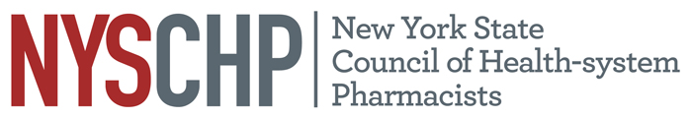
230 Washington Ave Extension, Albany NY 12203 - 518-456-8819

2021 HOUSE OF DELEGATES

Virtual Meeting, First Session

April 14, 2021

REPORT OF THE EXECUTIVE DIRECTOR

Shaun C. Flynn

This report is for consideration by the New York State Council of Health-system Pharmacists House of Delegates only and does not represent official policy until approved the House of Delegates.

- Responsibilities of the Executive Director

The Executive Director shall be responsible for the administrative activities of NYSCHP including direction of all operations, programs and activities. The Executive Director shall at all times, support the vision, mission and goals of NYSCHP.

- Operations

  - Administration
      - The 2022 Annual Assembly will be held on April 7 through April 10, at the Saratoga Hilton, Saratoga Springs, NY.
      - Tri-State Educational Program is tentatively scheduled for October 1, 2021 in Tarrytown NY.
      - NYSCHP continues to provide administrative support for the New York State Council of Health-system Pharmacists Research and Education Foundation (REF) and assists in the administration of the REF awards.
      - As of January 1, 2021, the Executive Director is now the sole lobbyist for the Council. Executive Director advocacy efforts have focused on Executive Orders related to the Covid-19 pandemic, reintroduction of the CDTM and immunization legislation, state budget and the implementation of the technician legislation.
      - The Executive Director conducted a search and review process for a new and more robust webinar platform to replace Anymeeting. After reviewing all available products Webex was selected. The new software has been implemented and the change will save the Council $1,200 per year.
      - The financial mitigation efforts implemented in the wake of the Covid-19 crisis and the cancellation of the 2020 Annual Assembly were successful in stabilizing the Council’s finances, greatly reducing the any chance of insolvency. The Council reduced spending in this year’s budget from $649,250 to $393,900. This put the Council in a strong position to handle the move to a virtual 2021 Annual Assembly which is expected to reduce income from that event by 2/3. In order to provide for additional reserves to help weather the economic downturn, the Board of Directors on the recommendation of the Executive Director applied for and received a $150,000 Small Business Administration loan. I will be working on a proposed budget for the 2021-2022 budget year that will begin the process of a phased in restoration of some of the cuts made last year. Certain cuts like the lobbyist expense will remain in place for the foreseeable future.
      - Social media activity for the Council continues to grow with a strong focus on advocacy activity and education. As a result of these efforts, we continue to increase our followers on all of the Council’s accounts. This year the Council added a YouTube page to our social media portfolio.

- Activities

Nationally: I have represented NYSCHP at the following ASHP events: the 2020 Virtual Midyear Clinical Meeting, 2020 Virtual Presidential Officers Retreat, ASHP Covid-19 calls and the ASHP virtual state affiliates meetings.

State: On the state level, I have attended meetings with the Alliance of New York Licensed Health Professionals (ANYLHP), IPRO, Empire State Society of Association Executives (ESSAE), NYS Pharmacy Conference, NYS Senate, NYS Assembly, NYS Office of the Professions, the State Education Department, State Department of Health, Bureau of Narcotic Enforcement and NYS Board of Pharmacy. NYSCHP continues to work collaboratively with PSSNY, the Chain Pharmacy Association and ASCP to promote our mutual legislative agendas. I will continue to work to expand the Council’s visibility in these areas and pursue avenues for NYSCHP to provide input with regard to professional and legislative issues that promote and enhance the pharmacy profession.

Respectfully submitted,

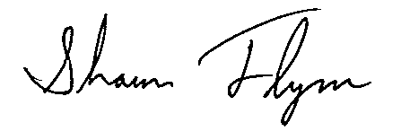
Shaun C. Flynn
Executive Director

