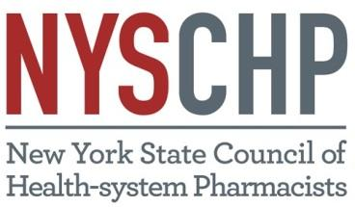

PREPARATION OF POSTER ABSTRACTS
Guidelines and General Information
Applications must be received by February 1, 2022

- Abstracts will be submitted via online form available on nyschp.org beginning January.
- Failure to comply with these guidelines may result in rejection of poster abstract.

- Abstracts are limited to 300 words.
  - Word counts do not include title, author information or section headings

- Abstracts should include the following: (see below abstract criteria)
- Original Research: Introduction/Background, Objective(s), Methods, Results, and Conclusions. Abstracts with Results/Conclusion in progress will be accepted. If accepted, a finalized abstract must be submitted following the conference to be included in website publication.
- Case Reports: Introduction/Background, Case, Discussion, Conclusions
- Systematic reviews/Meta-analyses: Introduction/Background, Methods, Results, Discussion, Other
- (Clinical) Pharmacy Services: Service/Program, Justification/Documentation, Adaptability, Significance

- Proofread abstracts carefully, particularly doses, numerical values, and drug names. After the deadline, changes cannot be made to the title or content. Standard abbreviations may be used without definition (e.g., mg/dl, mMol/L, ng/ml), but nonstandard abbreviations must be placed in parentheses after the first use of the word in the abstract body. It is important to keep nonstandard abbreviations to a minimum; this allows ease of readability and understanding of the abstract. When presenting a medication, use only the generic name.

- Abstracts with a commercial tone will not be accepted
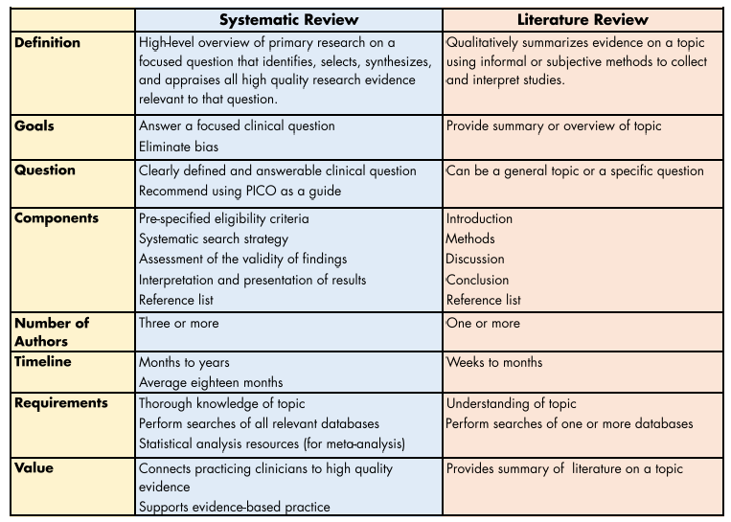
- Abstracts which review existing literature will not be accepted.

- It must be indicated in the abstract that all clinical research was approved by the appropriate ethics committee or institutional review board and, if appropriate, informed consent was obtained for all subjects.

- Encore presentations from the previous 12 months will be accepted, although not eligible for awards. Please denote in the submission if the presentation was previously submitted, the date submitted and the organization it was submitted to. Encore presentation presented and published elsewhere (proceedings or professional journal) may be submitted but will not be published on the website.

Review Criteria by Research Type listed on following pages:
- All Criteria items included (Yes)
- All Criteria with score: (≥ 2)
- Readability and Organization Score: (≥ 2)
- Overall Impression Score: (≥ Good)
- Recommendation: Accept
ABSTRACT REVIEW CRITERIA: Original Research

- Introduction/Background (max 3 points)
- Establishes the importance of research
- Describes a need for the research: (generates new knowledge; answers whether a previous observation can be replicated; documents if previous findings can be applied to a different population; or determines if improved measurement techniques can clarify a relationship)
- Provides relevance of research to clinical pharmacy
- None of the above
- Objective(s) (max 3 points)
- Is/Are focused/simple/specific
- Is/Are important
- Is/Are feasible to study/testable
- None of the above
3. Methods (Study Design) (max 3 points)
- Is a documentable quantitative, qualitative, or hybrid study design
- Is concisely stated
- Is the most efficient study design needed to get a satisfactory answer to the research question
- None of the above
4. Methods (General) (max 3 points)
- Describes a stepwise approach to what was done
- Identifies primary end points/outcomes
- Maximizes internal and external validity, and minimize bias/error
- None of the above
5. Methods (Data Analysis/Statistics) (max 3 points)
- Is deliberate and systematic
- Uses optimal inferential or descriptive statistics
- Promotes a conservative approach to data analysis (eg. provides alpha/level of significance, power, non-inferiority margin or equivalent)
- None of the above
6. Results (max 3 points)
Results and Conclusions may be stated as “in progress” if submitting as “Research in Progress”
- Addresses the research question
- Uses design-appropriate raw data to characterize the primary and secondary outcomes with appropriate statistical indices
- Avoids interpretations, explanations, and speculations
- None of the above
7. Conclusions (max 3 points)
- Addresses the original research question or hypothesis
- Are supported by the results without extrapolating beyond the results of the study
- Do not repeat results or introduce findings not presented in the results section
- None of the above
8. Readability and Organization (max 3 points)
- Clearly communicates thoughts and concepts
- Utilizes professional language and a concise writing style
- Is free of grammatical or technical errors
- None of the above
9. Overall Impression: Abstract is:
- Very Poor
- Poor
- Good
- Very Good
- Outstanding
10. Recommendation
- Accept
- Reject

ABSTRACT REVIEW CRITERIA: Case Reports

- Introduction/Background (max 3 points)
- Defines what is unique about this case
- Describes what the case adds to the medical literature
- Justifies importance of the case report
- None of the above
- Case (max 3 points)
- Presents the de-identified patient’s chief complaint
- Lists and briefly substantiates diagnoses
- Chronologically describes interventions and summarizes relevant outcomes
- None of the above
3. Discussion (max 3 points)
- Compares and contrasts the case to the relevant medical literature available
- Identifies strengths and limitations in the interventional approach to this case or in the information available about the case
- Proposes a testable hypothesis based on finding of the case
- None of the above
4. Conclusions (max 3 points)
- States the “take-away” points from the case
- Does not simply reiterate finding presented in the case
- Does not introduce new interventions or finding which should’ve been presented previously in the case
- None of the above
5. Readability and Organization (max 3 points)
- Clearly communicates thoughts and concepts
- Utilizes professional language and a concise writing style
- Is free of grammatical or technical errors
- None of the above
6. Overall Impression: Abstract is:
- Very Poor
- Poor
- Good
- Very Good
- Outstanding
7. Recommendation
- Accept
- Reject

ABSTRACT REVIEW CRITERIA: Systematic Review/Meta-analyses

- Introduction/Background (max 3 points)
- Provides the research question to be answered
- Defines the population or participants included
- Identifies the intervention or exposure of interest, specifies the comparators and outlines the outcomes
- None of the above
- Methods (max 3 points)
- Gives express eligibility criteria for inclusion
- Indicates how thorough the search was by listing information sources searched and date of last search (PRISMA recommends listing all sources if <4 and listing top 3 if >3 used)
- Briefly indicates how the risk of bias was assessed
- None of the above
3. Results (max 3 points)
- Highlights the number and type of included studies and participants, and relevant characteristics
- Provides data for the review’s main outcomes, preferably indicating the number of studies and participants for each; if a meta-analysis was done include summary of measurers and confidence intervals
- Clearly indicates the direction of effect, i.e. which group was favored
- None of the above
4. Discussion (max 3 points)
- Briefly states strengths and limitation of the evidence
- Presents a general interpretation of the results
- Emphasizes important implications
- None of the above
5. Other (max of 3 points)
- Reveals the primary source of funding; if none that is stated
- Provides a statement of potential conflicts of interest; if none that is state
- Lists the registration number and registry name; if none that is stated
6. Readability and Organization (max 3 points)
- Clearly communicates thoughts and concepts
- Utilizes professional language and a concise writing style
- Is free of grammatical or technical errors
- None of the above
7. Overall Impression: Abstract is:
- Very Poor
- Poor
- Good
- Very Good
- Outstanding
8. Recommendation
- Accept
- Reject

ABSTRACT REVIEW CRITERIA: (Clinical) Pharmacy Services

- Service or Program (max 3 points)
- Describes what the service or program does
- Describes where the service was performed or delivered and who it was provided to/for
- Describes how the service or program was developed and delivered and who provided the service/program
- None of the above
- Justification/Documentation (max 3 points)
- Describes how the program or service met a need
- Provides measurers for an evidence of success (quantitative or qualitative)
- Provides enough detail to permit others to assess adaptability and impact
- None of the above
3. Adaptability (max 3 points)
- Describes how the program or service appropriately generalizes to setting where it should be implemented
- Describes how the program or service is matched to the target population reported
- Describes how the program or service is able to be delivered by equivalently qualified providers and successfully implemented as recommended
- None of the above
4. Significance (max 3 points)
- Provides development , advancement or positioning of clinical pharmacists (including students, trainees, and/or practicing clinical pharmacists) to optimize clinical pharmacy practice
- Has convincing significant and is likely to make a difference in the specified target population or market
- Is not repetitious of previous work in the specified setting
- None of the above
5. Readability and Organization (max 3 points)
- Clearly communicates thoughts and concepts
- Utilizes professional language and a concise writing style
- Is free of grammatical or technical errors
- None of the above
6. Overall Impression: Abstract is:
- Very Poor
- Poor
- Good
- Very Good
- Outstanding
7. Recommendation
- Accept
- Reject

