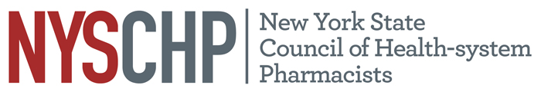
230 Washington Ave Extension, Albany NY 12203 - 518-456-8819

To: Delegates and Alternate Delegates
2022 House of Delegates

From: Stephanie Seyse
Chair, House of Delegates

Subject: First House of Delegates Mailing

The Rules and Regulations of the House of Delegates require all proposed amendments to the Constitution and Bylaws be mailed to the delegates and alternate delegates sixty (60) days in advance of the meeting. Please find the following posted on this website:

- 2022 Roster of Delegates
- Minutes of the 2021 House of Delegates Meeting
- Minutes of the December 2021 Virtual House of Delegates Meeting
- Notice of Open Hearing (4/7/22)
- Notice of Resolutions Committee Conference Call (3/31/22)
- 2019 House of Delegates Regulations
- Regulations of the House of Delegates – Draft Revisions

To complete the delegate kit, a second mailing will be sent by March 7, 2022, thirty (30) days in advance of the meeting as required by the Bylaws.

Enclosures

cc: Local Chapter Presidents
Active Past Presidents
Board of Directors

