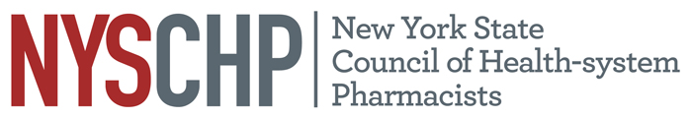
230 Washington Ave Extension, Albany NY 12203 - 518-456-8819

TO: Delegates, Alternate Delegates and Past Presidents
2022 House of Delegates

FROM: Stephanie Seyse
Chair, House of Delegates

SUBJECT: Notice of Open Hearing on April 7

The Open Hearing will take place on Thursday, April 7, 2022 from 11:30 AM to 12:30 PM.
The purpose of the meeting is to provide all Council members with the opportunity to discuss any topic related to health-system pharmacists in New York State, the operation and activities of the NYSCHP, and any appropriate matters for consideration by the NYSCHP House of Delegates and NYSCHP Board of Directors.

All delegates are requested to canvass the membership of your chapter and bring forward matters of concern. In addition, members should be encouraged to attend and participate in this session.

If you have any questions, please feel free to contact the Council Office at (518) 456-8819.

Thank you.
Agenda
- Greetings and HOD Overview Stephanie Seyse, Chair
- Parliamentary Procedure Overview Tom Lombardi, Parliamentarian
- Finance Report William Prescott, Treasurer
- Legislative Update Andrew Kaplan, Vice President Public Policy
- Resolutions Update Heide Christensen, Chair Committee on Resolutions
- Membership Update Timothy Hutcherson, Director of Chapter Services
- Open Forum Delegates and the BOD

