Committee: Western New York Society of Health-systems Pharmacists
Topic: Medical Misinformation Shared on Social Media Platforms
Sponsored: Aubrey Defayette; Kristen Fodero; Brian Kersten

Medical Misinformation Shared on Social Media Platforms

Whereas, Medical misinformation is the spread of inaccurate medical information with the purpose of misleading those who encounter it,

Whereas, Social media platforms have been used during the COVID-19 pandemic to assist in keeping the public accurately informed, but also to spread medical misinformation,

Whereas, Information posted to social media platforms is not consistently reviewed for credibility or accuracy prior to its distribution nor is the removal of medical misinformation performed regularly,

Whereas, Most Americans obtain news and information via social media platforms, therefore, be it

Resolved That: The New York State Council of Health-system Pharmacists supports social media platforms adjusting their content moderation policies to routinely identify and address medical misinformation.

Date: __2/4/2022______________

By: _____ Aubrey Defayette; Kristen Fodero; Brian Kersten ______

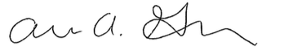
Aubrey Defayette
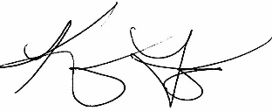

Kristen Fodero

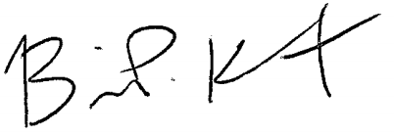
Brian Kersten

