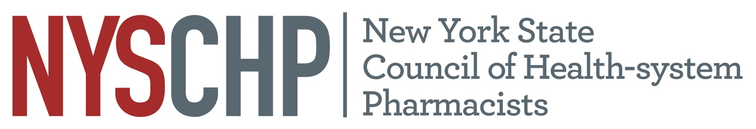

New York State Council of Health-system Pharmacists

REPORT OF Director of Education and Professional Development

Nicole Cieri-Hutcherson, PharmD, BCPS, NCMP

April 7, 2022

- Responsibility of the Division

The charge of the Director of Education and Professional Development as defined in the Constitution and Bylaws of the NYSCHP, is to be responsible for: “conducting programs of continuing education including the Annual Assembly and Midyear Clinical Programs; creating, developing, and monitoring all educational activities including, but not limited to, competencies and certification of continuing education credit. He/she is also responsible for developing and being sensitive to the educational needs of the membership through the resources of the Council and affiliated chapters and the Director of Chapter Services.”

- Committees of the Division
Education and Professional Development Committee
Chair: Chung-Shien Lee
- Student Competition Subcommittee Co-Chairs: Wes Kufel and Kelly Bach
- Student Education/Development Subcommittee Co-Chairs: Shireen Farzadeh and Samantha Moore
- Poster Subcommittee Chair: Ami Shah
- TriState Subcommittee Chair: TBD

Members
Last Name | First Name | E-mail
Aberle | Caitlin | Caitlin.Aberle@wmchealth.org
Bach | Kelly | kelly.bach@acphs.edu
Byland | Faiyh | Fmslaton@gmail.com
Cassidy | Ruth | rcassidy@sbhny.org
Cheng-Lai | Angela | ACHENG@montefiore.org
Chin-Hon | Jamie | jamiehchin@gmail.com
Christensen | Heide | Heide.Christensen@chsli.org
Cieri- Hutcherson | Nicole | necieri@buffalo.edu
Clark | Collin | collincl@buffalo.edu
Cohen | Henry | Henry.Cohen@touro.edu
Defayette (Gawron) | Aubrey | aagawron3@gmail.com
Fain | Alina | alinafain90@gmail.com
Farzadeh | Shireen | shireenf@gmail.com
Fellows | Shawn | sfellows@sjfc.edu
Flynn | Shaun | sflynn@nyschp.org
Freire | Carmen | Trabcarmen@gmail.com
Goldstein | Matthew | mattg81650@aol.com
Jakubovics (Friedman) | Michelle | Michelle.Jakubovics@touro.edu
Khaimova | Rebecca | rkhaimova@gmail.com
Klang | Mark | klangm@mskcc.org
Kploany | Sefa | skploany@gmail.com
Kufel | Wesley | wkufel@binghamton.edu
Kuriakose | Tobin | tobin.kuriakose15@my.stjohns.edu
Lam | Sum | Lams1@stjohns.edu
Lee | Chung-Shien | leec3@stjohns.edu
Lee | Yumi | leey2@stjohns.edu
Liaw | Samantha | SLiaw@northwell.edu
Long | Jason | jlong181@gmail.com
Magaldi | Tom | magalditom@gmail.com
Mondiello | Taryn | mondiellot@gmail.com
Paskovaty | Alla | paskovaa@gmail.com
Pinto | Joseph | joseph.pinto@mountsinai.org
Shah | Ami | amishah1221@gmail.com
Sobrera | Maria | MSorbera526@gmail.com
Symoniak | Melanie | msymoniak@sjfc.edu
Wang | Shan | shan.wang@nyulangone.org
Willner | Debra | devorawillner@gmail.com
Zammit | Kimberly | zammitkt@gmail.com
Zada | Ilanit | Ilanit.zada1@gmail.com

Activities: Past https://nyschp.memberclicks.net/nyschp-webinar

Date | Time | Day of Week | Title | Program at Which Program was Held | Speaker(s) | Chapter Webinar is Originally From | Chapter that Speaker is a Member of |  | Reg | Att
5/19/2021 | 12-1 PM | Wed | COVID-19 Update from Infectious Diseases Perspective by | Monthly Webinar | Patricia Saunders-Hao | Long Island |  | N/A | 199 | 97
5/27/2021 | 2-3:30 PM | Thurs | Work-life balance | Student Education Series | Bill Prescott | Original |  | Western | 25 | 10
6/8/2021 | 12-1 PM | Tues | Transplant Immunosuppression | Monthly Webinar | Nicholas A. Jandovitz and Nadine T. Breslin |  |  | - | 192 | 90
7/20/2021 | 6-7 PM | Tues | PTCE Crash Course and Medication Safety Review – Part 1 | Monthly Webinar | Adrian Chatham, Jamie Chin-Hon, Lilia Davenport | NYC |  | NYC | 176 | 79
7/29/2021 | 6-7 PM | Thurs | PTCE Crash Course and Medication Safety Review – Part 2 | Monthly Webinar | Sarah Amin, Matthhew Goldstein, Matthew Li | NYC |  | NYC | 161 | 60
8/24/2021 | 6-8 PM | Tues | NYSCHP: 2021 Critical Care Webinar Series - Session 1 | Miniseries | Kasia Gosek, Matthew Li | Original |  | NYC | 365 | 208
8/26/2021 | 6-8 PM | Thurs | NYSCHP: 2021 Critical Care Webinar Series - Session 2 | Miniseries | Samantha Moore, Kaitlin Landolf | Original |  | NYC | 301 | 145
9/20/2021 | 12-1 PM | Mon | Emerging Drug Trends | Monthly Webinar | William Eggleston | ST |  | ST | 180 | 97
10/1/2021 | All day | Fri | TriState Program | Tristate | Multiple | Original |  | N/A | - | -
10/6/2021 | 12-1 PM | Wed | Antiplatelet or anticoagulants in TAVR | NYS ACCP Collaboration | Caitlin Kulig | Original |  | N/A | 110 | 53
11/8/2021 | 12-1 PM | Mon | Medical Marijuana in NYS | CEI Collaboration | Jessica Robinson-Papp | Original |  | N/A | 149 | 66
12/14/2021 | 12-1 PM | Tues | New Practitioner Webinar: Extinguishing Burn Out | New Practitioner Collaboration | Danielle Cabral and Rebecca Khaimova | Original |  | LI, Royals | 152 | 65
1/11/2022 | 7-9 PM | Tues | NYSCHP: 2022 Geriatrics Webinar Series - Session 1 | Miniseries | Shireen Farzadeh, John Noviasky | Original |  | NYC | 158 | 100
1/19/2022 | 7-9 PM | Wed | NYSCHP: 2022 Geriatrics Webinar Series - Session 2 | Miniseries | Robert Accetta, Kelly Ulen | Original |  | Central | 148 | 86

Annual Assembly 2021
- Attendance:
- Enduring CE credit claims for 30 days after the event: none
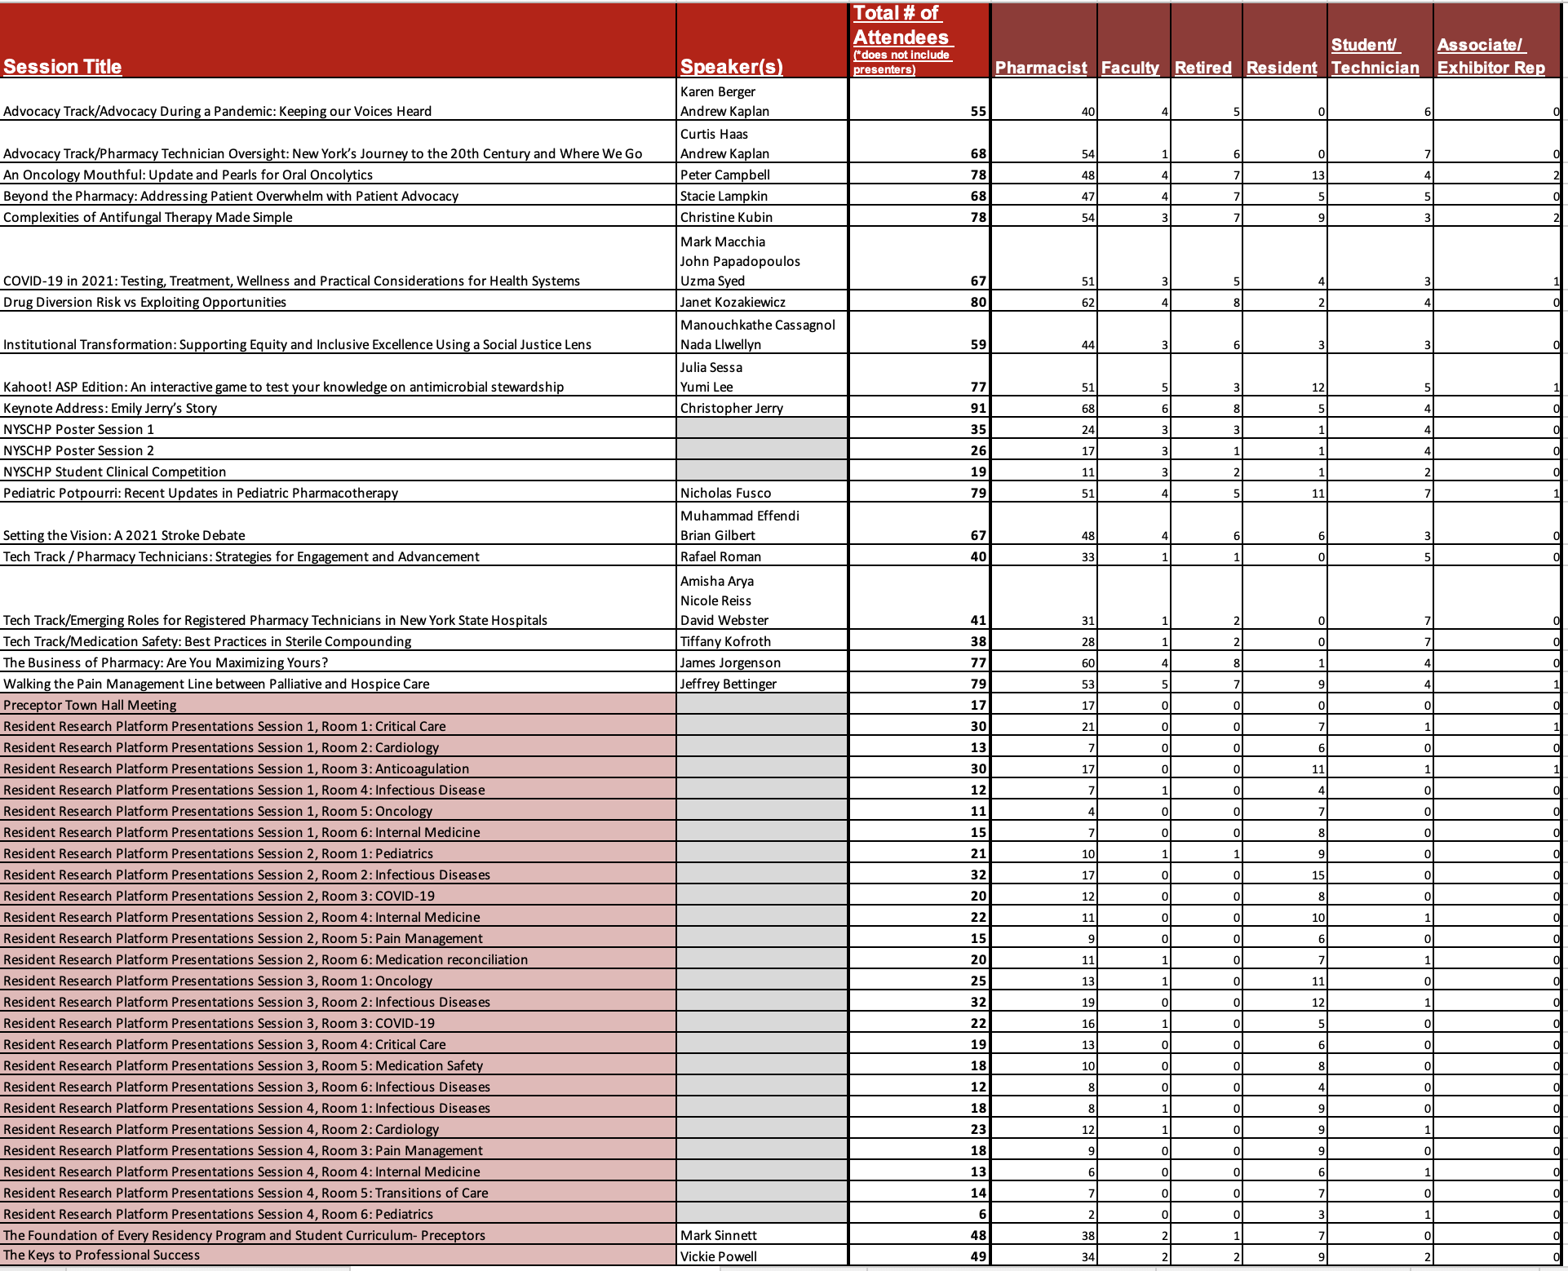

TriState 2021
- Attendance: 88 registrants, 86 attendees
- Vendors: 45 companies; 68 individuals

Activities: Future

Date | Time | Day of Week | Title | Program at Which Program was Held | Speaker(s) | Chapter Webinar is Originally From | Chapter that Speaker is a Member of
2/8/2022 | 12-1 PM | Tues | Pharmacy Advocacy: If Not You, Who? | Monthly Webinar | Samantha Paone and Rachel Quinn | Original | Royals, LI
3/10/2022 | 12-1 PM | Thurs | Best Practices in Establishing a Controlled Substance Diversion Surveillance Process | Monthly Webinar | Amisha Arya | Original | NYC
April 2022 | Annual Assembly | All Day | - | Annual Assembly | - | N/A | N/A
May 2022 |  |  | Reaccreditation of local programming | Monthly Webinar
June 2022 |  |  | Reaccreditation of local programming | Monthly Webinar
6/18/2022 | All day |  | Oncology Symposium | Oncology Symposium |  | Original
9/23/2022 | All day | Fri | TriState Programming | TriState | - | Original

Oncology Symposium 6/18/2022
- Venue: NYU Langone
- Educational programming
Time | Speaker(s) | Topic title
Saturday, June 18th, 2022  8:00 AM – 9:00 AM  PHARMACY TIMES |  | PHARMACY TIMES  Chronic Lymphocytic Leukemia: Optimizing Patient Care Through Expert Knowledge of Drug Therapies and Treatment-Related Toxicities
Saturday, June 18th, 2022  9:00 AM – 10:00 AM  ASHP SPEAKER |  | Immunotherapy
Saturday, June 18th, 2022  10:00 AM – 11:00 AM  KEYNOTE | Benyam Muluneh | KEYNOTE: The Next Frontier: Moving from Innovation to Optimization
Saturday, June 18th, 2022  11:00 AM – 12:00 PM  EXHIBITS | EXHIBITS | EXHIBITS
Saturday, June 18th, 2022  12:00 PM – 1:00 PM  PHARMACY TIMES |  | PHARMACY TIMES  Caring for Patients With Multiple Myeloma Through Pharmacist-Directed Supportive Care and Toxicity Management Strategies
Saturday, June 18th, 2022  1:00 PM – 2:00 PM | Stephen Eng  Nicole Daukshus | CAR T-cell Therapies: Current Treatment Strategies in the Adult and Pediatric Population
Saturday, June 18th, 2022  2:00 PM – 3:00 PM | Peter Campbell  Jordan Pleskow | COVID-19 and Cancer: The Current Impact on Treatment and Supportive Care
Saturday, June 18th, 2022  3:00 PM – 4:00 PM  Resident Clinical Pearls | Alice Wang | The ART of Chemotherapy: Navigating Interactions Between Antiretrovirals and Chemotherapy
 | Chandni Patel | Role of Glucarpidase in Delayed Methotrexate Clearance
 | Alyssa Cendagorta | Review of Asparaginase Toxicity and Adult Dose Capping
 | Angelica Bevinetto | Therapeutic Drug Monitoring (TDM) of Asparaginase in the Pediatric Population

Geriatrics Certificate 2022-2024
- Registration open: https://nyschp.memberclicks.net/index.php?option=com_mcform&view=ngforms&id=2114150
- Certificate Information: 8 total credits required for certificate:
  - Total: At least 12 credits total of CE offered over 2 year period (as live and home study)
  - Home study: Up to 50% of 8 credits may be home study
    - 6 home study credits will be offered over a period of 2 years
  - Live: At least 1 live CE will be offered at the Annual Assembly, 2 live CE offered throughout year (webinars or miniseries)
    - 6 live offered over 2 years

Other Future Plans:
- Replacement of local webinar reaccreditation with original content to meet certificate programs
- Future certificate programs:
  - Diversity certificate program
  - Leadership certificate program

- Strategic Plan Tasks: Status Update
- Engage

Strategy | Action Items | Notes
Develop innovative and attractive programming and networking opportunities for all members. | Subcommittee meetings for webinar, Tristate and Annual Assembly programming, specialty symposia | Work with associated directors and committee chairs
Continue surveying members & potential members to identify needs, trends, and effectiveness of current offerings. | Annual membership education interest surveys  Technician education interest surveys  Student education interest surveys  Annual Assembly education survey | Work with associated directors and committee chairs
Increase greater awareness and participation in NYSCHP programming. | Regular email blasts and social media calendar review.  Plan in future to synchronize Podcasts, YouTube Channel, Webinar CE if possible | Work with Communication Committee

- Lead

Strategy | Action Items | Notes
Design and implement annual leadership development cycle, including recruitment, orientation, and key governance documents and resources. | Annual call for program chairs/subcommittee chairs in the summer conducted and selections made.  Planning for EPD chair succession ongoing.
Continue to develop Committees, ensuring structure and goals meet Council’s needs. | Subcommittee reports at quarterly meetings

- Advocate

Strategy | Action Items | Notes
Provide routine reporting methodology for all government affairs issues and updates. | Advocacy CE track during AA Advocacy CE during Advocacy Week | Work with VP Public Policy and associated committees
Increase interest and participation in Lobby Day. (advocacy week) | Advocacy CE during Advocacy Week

- HOD Recommendations: Status Update

- Kim Zammit : When a board member or committee chair speaks at NYSCHP events on topics directly related to their board/committee responsibilities provision of an honorarium should be waived.
  - Discussed at EPD committee meeting and with EPD Committee Chair. Committee has moved forward with requesting gratis presentations from board members and committee chairs, regardless of topic to avoid conflicts of interest.
- Michele Kaufman: Monthly Webinar's be presented as an encore in the evening as well as during the 12:00 noon - 1:00 pm timeslot.
  - Discussed at EPD committee meeting and with EPD Committee Chair. Due to limited council and committee resources, the committee is in agreement that we are unable to offer this at this time. We will continue to make sure to offer webinars at varying times/days of the week throughout the year with special emphasis on technician programming being offered in the evening as we did this past summer. The miniseries also provides an opportunity for 8 CE credits per year in the evenings that are also accredited for pharmacists and technicians. All webinars that have speaker permission are also recorded and available with slides on the NYSCHP website for non-CE viewing.

- Review of Position Statements: Status Update
None at this time

Respectfully submitted,

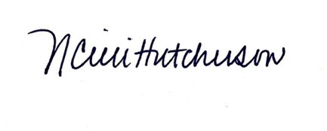
Nicole Cieri-Hutcherson, PharmD, BCPS, NCMP
Director, Education and Professional Development

