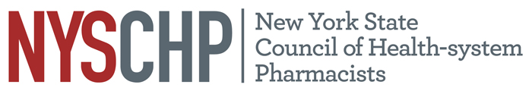
230 Washington Ave Extension, Albany NY 12203 - 518-456-8819

2022 HOUSE OF DELEGATES

Saratoga City Center, Saratoga Springs NY

April 7, 2022

REPORT OF THE EXECUTIVE DIRECTOR

Shaun C. Flynn

This report is for consideration by the New York State Council of Health-system Pharmacists House of Delegates only and does not represent official policy until approved the House of Delegates.

- Responsibilities of the Executive Director

The Executive Director shall be responsible for the administrative activities of NYSCHP including direction of all operations, programs and activities. The Executive Director shall at all times, support the vision, mission and goals of NYSCHP.

- Operations

  - Administration
      - The 2023 Annual Assembly will be held on April 19 through April 23, at the Saratoga Hilton, Saratoga Springs, NY.
      - Tri-State Educational Program is tentatively scheduled for September 23, 2022 in Tarrytown NY.
      - NYSCHP continues to provide administrative support for the New York State Council of Health-system Pharmacists Research and Education Foundation (REF) and assists in the administration of the REF awards.
      - The Executive Director continues to serve as the sole lobbyist for the Council. Executive Director advocacy efforts have focused on CDTM, CLIA waived testing, and white bagging legislation. While lobbying is technically being covered, only basic functions are able to be performed under this arrangement.
      - The Council implemented a new webinar platform to replace Webex. Zoom was selected due to the ease of use for our volunteers.
      - The financial mitigation efforts implemented in the wake of the financial strain placed on the Council by the pandemic have been successful in stabilizing the organization’s finances. Due to a combination of the significant budget cuts, staff give backs, and a successful virtual Annual Assembly, the Council was able to recoup most of the previous year’s losses. The 2021-2022 budget restored much of the funding cuts made in the prior year based on the assumption that organization would be able to return to an in-person Annual Meeting. The Council’s 2021-2022 budget was restored to $577,750 from $393,900 the year before. Most of the increase will go to expenses associated with the return to an in-person Annual Assembly. While this was a significant improvement, it is still well short of the pre-pandemic budget of $649,250. As a result of this, the Council was unable to restore funding for a lobbyist, staff travel and several other budget lines. Certain cuts like the lobbyist expense may have to remain in place for the foreseeable future posing significant operational challenges. It is our hope that a successful Annual Assembly will allow us to repay the $150,000 Small Business Administration loan in full this Summer.
      - Social media activity for the Council continues to grow with a new focus on Instagram and You Tube. As a result of these efforts, we continue to increase our followers on all of the Council’s accounts.

- Activities

Nationally: I have represented NYSCHP at the following ASHP events: the 2021 Virtual Midyear Clinical Meeting, 2021 Virtual Presidential Officers Retreat, ASHP Legislative Calls and the ASHP virtual state affiliates meetings.

State: On the state level, I have attended meetings with the Alliance of New York Licensed Health Professionals (ANYLHP), IPRO, Empire State Society of Association Executives (ESSAE), NYS Pharmacy Conference, NYS Senate, NYS Assembly, NYS Office of the Professions, the State Education Department, State Department of Health, Bureau of Narcotic Enforcement and NYS Board of Pharmacy. NYSCHP continues to work collaboratively with PSSNY, the Chain Pharmacy Association and ASCP to promote our mutual legislative agendas. I will continue to work to expand the Council’s visibility in these areas and pursue avenues for NYSCHP to provide input with regard to professional and legislative issues that promote and enhance the pharmacy profession.

Respectfully submitted,

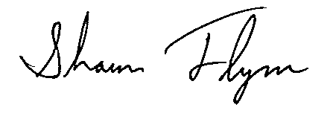
Shaun C. Flynn
Executive Director

