Committee: Constitution & By-laws
Topic: Nomenclature for NYSCHP Affiliated Chapters
Sponsored: Robert DiGregorio (BOD), Maria Longo (Royals)

Whereas, The New York State Council of Health-systems Pharmacists (NYSCHP) has affiliated chapters throughout New York State, and,
Whereas, NYSCHP is known by the abbreviation NY SCH P, as well as by the phrase "the Council", and, Whereas, The abbreviated name is commonly pronounced as "Nice-Ship" or /nTSHip/, and,
Whereas, It is confusing when other organizations, such as the affiliated chapters, utilize nomenclature that can look or sound like the NYSCHP nomenclature, therefore, be it

Resolved That:

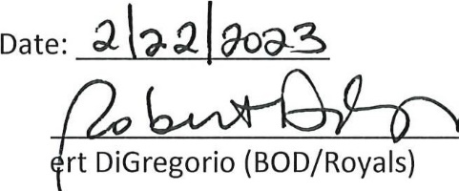
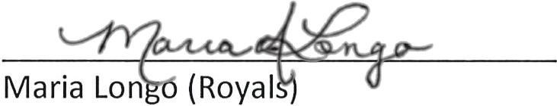
The New York State Council of Health-systems Pharmacists will be known by the abbreviation NYSCHP, which is to be pronounced phonetically as "Nice-Ship" or /nTSHip/. The affiliated chapters of the New York State Council of Health-system Pharmacists shall not use nomenclature that could look or sound alike, or otherwise be mistaken for that of that of the Council.
By:
Rob

Resolutions should be emailed to Shaun Flynn, sflynn@nyschp.org

