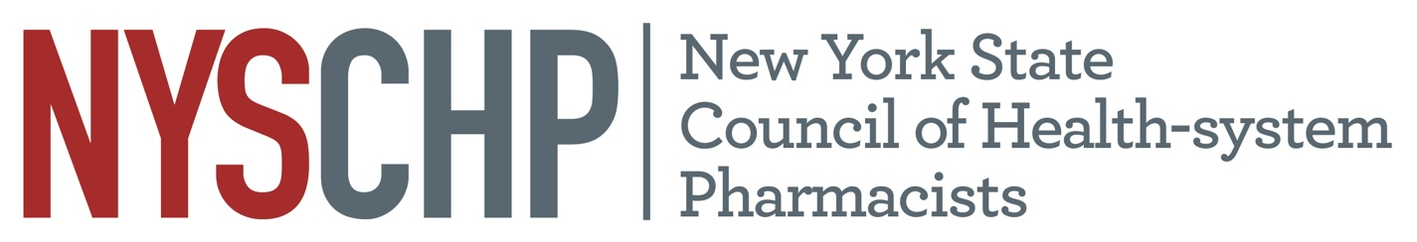

New York State Council of Health-system Pharmacists

REPORT OF Director of Education and Professional Development

Nicole Cieri-Hutcherson, PharmD, BCPS, NCMP

April 21, 2023

- Responsibility of the Division

The charge of the Director of Education and Professional Development as defined in the Constitution and Bylaws of the NYSCHP, is to be responsible for: “conducting programs of continuing education including the Annual Assembly and Midyear Clinical Programs; creating, developing, and monitoring all educational activities including, but not limited to, competencies and certification of continuing education credit. He/she is also responsible for developing and being sensitive to the educational needs of the membership through the resources of the Council and affiliated chapters and the Director of Chapter Services.”

- Committees of the Division
Education and Professional Development Committee
Chair: Chung-Shien Lee
- Student Education and Competition Subcommittee Co-Chairs: Samantha Moore, Shireen Farzadeh
- Poster Subcommittee Chair: Kelsey Gregorie
- TriState Subcommittee Co-Chairs: Carmen Freire, Alla Paskovaty
- Oncology Symposium Chair: Chung-Shien Lee

Members

Last Name | First Name | E-mail
Aberle | Caitlin | Caitlin.Aberle@wmchealth.org
Byland | Faith | Fmslaton@gmail.com
Cassidy | Ruth | rcassidy@sbhny.org
Cheng-Lai | Angela | ACHENG@montefiore.org
Chin-Hon | Jamie | jamiehchin@gmail.com
Christensen | Heide | Heide.Christensen@chsli.org
Chung | Soon Jae | soonjaechung@gmail.com
Cieri- Hutcherson | Nicole | necieri@buffalo.edu
Clark | Collin | collincl@buffalo.edu
Cohen | Henry | Henry.Cohen@touro.edu
Cohen | Nicolette | nicoletc@optimum.net
DiGregorio | Robert | rdigregorio@tbh.org
Farzadeh | Shireen | shireenf@gmail.com
Fellows | Shawn | sfellows@sjfc.edu
Flynn | Shaun | sflynn@nyschp.org
Freire | Carmen | Trabcarmen@gmail.com
Gregoire | Kelsey | kviolanti@yahoo.com
Guarino | Melissa | 99mguarino1@chsbuffalo.org
Khaimova | Rebecca | rkhaimova@gmail.com
Klang | Mark | klangm@mskcc.org
Kploany | Sefa | skploany@gmail.com
Kufel | Wesley | wkufel@binghamton.edu
Kuriakose | Tobin | tobinkuriakose@gmail.com
Lam | Sum | Lams1@stjohns.edu
Lee | Chung-Shien | leec3@stjohns.edu
Lee | Jennifer | jennleeptl@gmail.com
Lee | Yumi | leey2@stjohns.edu
Liu | Angel | angelliupharmd@gmail.com
Lombardi | Christina | Christina.Lombardi@sphp.com
Magaldi | Tom | magalditom@gmail.com
Moore | Samantha | moores@stjohns.edu
Paskovaty | Alla | paskovaa@gmail.com
Pinto | Joseph | joseph.pinto@mountsinai.org
Shah | Ami | amishah1221@gmail.com
Toribio | Crystal | Crystal.Toribio@mountsinai.org
Longo | Maria | Maria.longo@liu.edu
Wang | Shan | shan.wang@nyulangone.org
Zammit | Kimberly | zammitkt@gmail.com

Student Education, Student Clinical Competition
Co-Chairs: Samantha Moore, Shireen Farzadeh
Christina Lombardi
Nicolette Cohen
Rebecca Khaimova
Shan Wang
Shawn Fellows
Carmen Freire
Wes Kufel
Yumi Lee
Kelsey gregoire
Faith Byland

Poster Session
Chair: Kelsey gregoire

Tristate
Co-chairs: Carmen Freire, Alla Paskovaty
Jennifer Lee
Mark Klang
Nicolette Cohen
Caitlin Aberle
Henry Cohen
Angel Liu
Joe Pinto
Ruth Cassidy
Samantha Moore
Heide Christensen
Tobin Kuriakose

Oncology Symposium
Jamie Chin-Hon
Christina Lombardi
S. Jae Chung
Angel Liu
Unassigned
Caitlin Aberle
Angela Cheng-Lai
Collin Clark
Sefa Kploany
Sum Lam
Tom Magaldi
Ami Shah
Maria Longo
Shan Wang
Kimberly Zammit
Melissa Guarino

Activities: Past https://nyschp.memberclicks.net/nyschp-webinar

Date | Time | Day of Week | Title | Program at Which Program was Held | Speaker(s) | Chapter Webinar is Originally From | Chapter that Speaker is a Member of |  | Reg | Att
3/10/2022 | 12-1 PM | Thurs | Best Practices in Establishing a Controlled Substance Diversion Surveillance Process | Monthly Webinar | Amisha Arya | Original |  | NYC | 238 | 123
4/8/2022 | Annual Assembly | All Day | See below | Annual Assembly | - | Original |  | - | - | -
5/3/2022 | 12-1 PM | Tues | Pharmacists in public health: lessons learned, learning, and have yet to learn | Monthly Webinar | Joy Snyder | Rochester |  | Non-mem | 131 | 76
6/2/2022 | 12-1 PM | Thurs | Pharmacist’s role in transgender and gender non-conforming care | Monthly Webinar | Anthony Gerber | Royals |  | Royals | 112 | 50
6//18/2022 | Onc Symposium | All Day | See below | Oncology Symposium | - | Original |  | - | - | -
7/26/2022 | 12-1 PM | Tues | A balancing act: safe opioid prescribing and opioid stewardship in the hospital setting | Monthly Webinar | Alexandra Varga | Westchester |  | Non-mem | 231 | 103
8/2/2022 | 7-9 PM | Tues | NYSCHP: 2022 Diabetes Webinar Series - Session 1 | Miniseries | Caitlyn Gordon and Nicole Albanese | Original |  | Non-mem, Western | 178 | 66
8/11/2022 | 7-9 PM | Thurs | NYSCHP: 2022 Diabetes Webinar Series - Session 2 | Miniseries | Krysta Shannon and Emma Gorman | Original |  | NYC, Western | 155 | 56
9/19/2022 | 12-1 PM | Mon | New pox on the block: understanding monkeypox | Monthly Webinar | Michael Bosco | LI |  | LI | 223 | 107
9/23/2022 | TriState | All Day | See below | Tristate | - | Original |  | - | - | -
11/17/2022 | 12-1 PM | Thurs | Pain management in substance use disorder | NYS ACCP Collaboration | Bennett Doughty, Ebtesam Ahmed | Original |  | Southern Tier, Royals | 307 | 147
12/1/2022 | 12-1 PM | Thurs | All I want for Christmas is medication safety | Monthly Webinar | Jennifer Lee, Angela Jiatu, Brian Kam | Original |  | Royals, LI | 272 | 182
1/25/2023 | 12-1 PM | Wed | Principles of Safe Medication Use and Deprescribing for Older Adults | Monthly Webinar | Collin Clark | Original |  | Western | 537 | 326
2/13/2023 | 12-1PM | Mon | 2022 CDC Clinical Practice Guideline for Prescribing Opioids for Pain | Monthly Webinar | Lisa Yamagishi | LI |  | Non-mem | 205 | 128

Annual Assembly 2022
- Session Attendance by Number Claiming Credit

Day | Session | Total Claiming Credit
Friday | Impact of Covid on Our Mental Health and Our Recovery - Pharm | 65
Friday | Impact of Covid on Our Mental Health and Our Recovery - Tech | 3
Friday | Keeping Eyes on the Shot Clock: Timely Updates on the COVID-19 Pandemic and Vaccination - Pharm | 44
Friday | Keeping Eyes on the Shot Clock: Timely Updates on the COVID-19 Pandemic and Vaccination - Tech | 2
Friday | From Struggles to Success: How to Conduct Difficult Conversations at Work – Pharm | 63
Friday | From Struggles to Success: How to Conduct Difficult Conversations at Work – Tech | 2
Friday | An Overview of Geriatric Considerations in COVID-19 – Pharm | 55
Friday | An Overview of Geriatric Considerations in COVID-19 – Tech | 1
Friday | How Low Can We Go? A Review of Literature Supporting Shorter Duration of Antibiotics – Pharm | 58
Friday | How Low Can We Go? A Review of Literature Supporting Shorter Duration of Antibiotics – Tech | 2
Friday | Compounding Updates for Technicians - How USP and FDA are Shaping the Conversation – Pharm | 7
Friday | Compounding Updates for Technicians - How USP and FDA are Shaping the Conversation – Tech | 4
Friday | What Every Pharmacist Should Know About Patients with Kidney Failure on Dialysis: A Primer – Pharm | 41
Friday | What Every Pharmacist Should Know About Patients with Kidney Failure on Dialysis: A Primer - Tech | 3
Friday | Supporting Equity and Inclusive Excellence using a Social Justice Lens – Pharm | 29
Friday | Supporting Equity and Inclusive Excellence using a Social Justice Lens – Tech | 0
Friday | ECMO in the Era of COVID-19: Optimizing Medication Management – Pharm | 26
Friday | ECMO in the Era of COVID-19: Optimizing Medication Management – Tech | 2
Friday | Creating, Refining, and Reporting Clinical Pharmacy Metrics – Pharm | 42
Friday | Creating, Refining, and Reporting Clinical Pharmacy Metrics – Tech | 1
Saturday | Keynote: The Game-Winning 3 – Pharm | 72
Saturday | Keynote: The Game-Winning 3 – Tech | 3
Saturday | 2021 FDA Drug Approvals - What You Need to Know – Pharm | 52
Saturday | 2021 FDA Drug Approvals - What You Need to Know – Tech | 2
Saturday | Spores and more: Updates in Clostridioides difficile – Pharm | 44
Saturday | Spores and more: Updates in Clostridioides difficile - Tech | 1
Saturday | A Pharmacists' Introduction to Clinical Pharmacogenomics - Pharm | 38
Saturday | A Pharmacists' Introduction to Clinical Pharmacogenomics – Tech | 0
Saturday | Implementation Science – A Primer for Pharmacists - Pharm | 48
Saturday | Implementation Science – A Primer for Pharmacists - Tech | 1
Saturday | Career Pathways for Pharmacy Technicians - Pharm | 5
Saturday | Career Pathways for Pharmacy Technicians – Tech | 4
Saturday | HIV Treatment and Prevention – Pharm | 35
Saturday | HIV Treatment and Prevention – Tech | 1
Saturday | Operationalizing Pharmacy Services for an Acute Hospital Care at Home Program: What is White Bagging? - Pharm | 56
Saturday | Operationalizing Pharmacy Services for an Acute Hospital Care at Home Program: What is White Bagging? - Tech | 1
Sunday | Coloring Outside the Lines: How to Prepare for the Future of Pharmacy – Pharm | 53
Sunday | Coloring Outside the Lines: How to Prepare for the Future of Pharmacy – Tech | 2
Sunday | Medication Safety Pearls – Pharm | 58
Sunday | Medication Safety Pearls - Tech | 1
Residency | Residency: Opening Session - Pharmacy Professional Development & Career Advancement | 53
Residency | Development and Implementation of a Formal Pharmacy Residency Research Certificate Program | 22
Residency | Residency Research Session 1 | 68
Residency | Residency Research Session 2 | 54
Residency | Residency Research Session 3 | 81
Residency | Residency Research Session 4 | 57
Student Competition | Student Clinical Competition: Brain Bowl - Pharm | 31
Student Competition | Student Clinical Competition: Brain Bowl - Tech | 0

Annual Assembly 2023
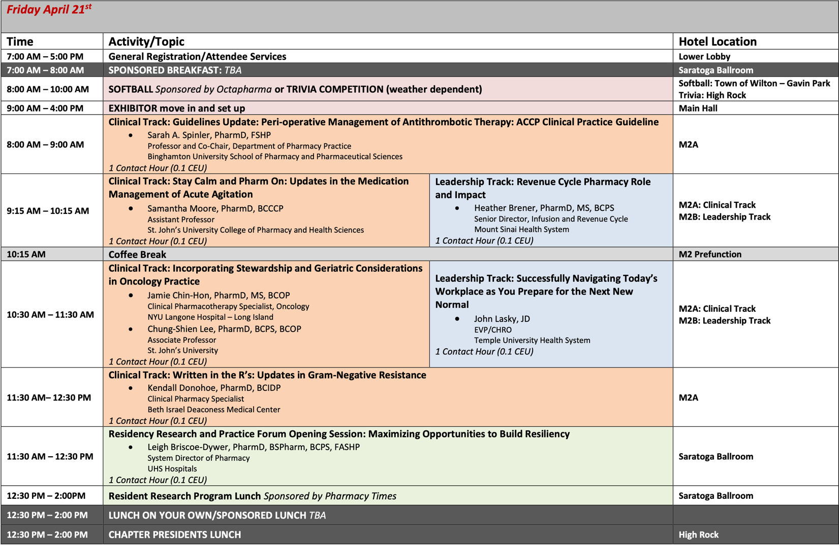
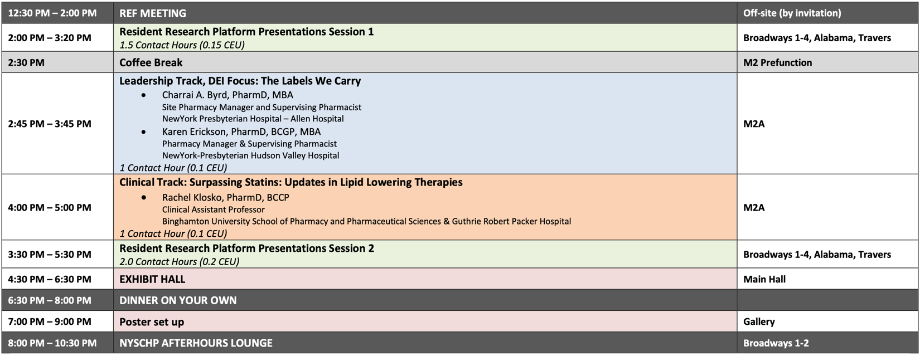

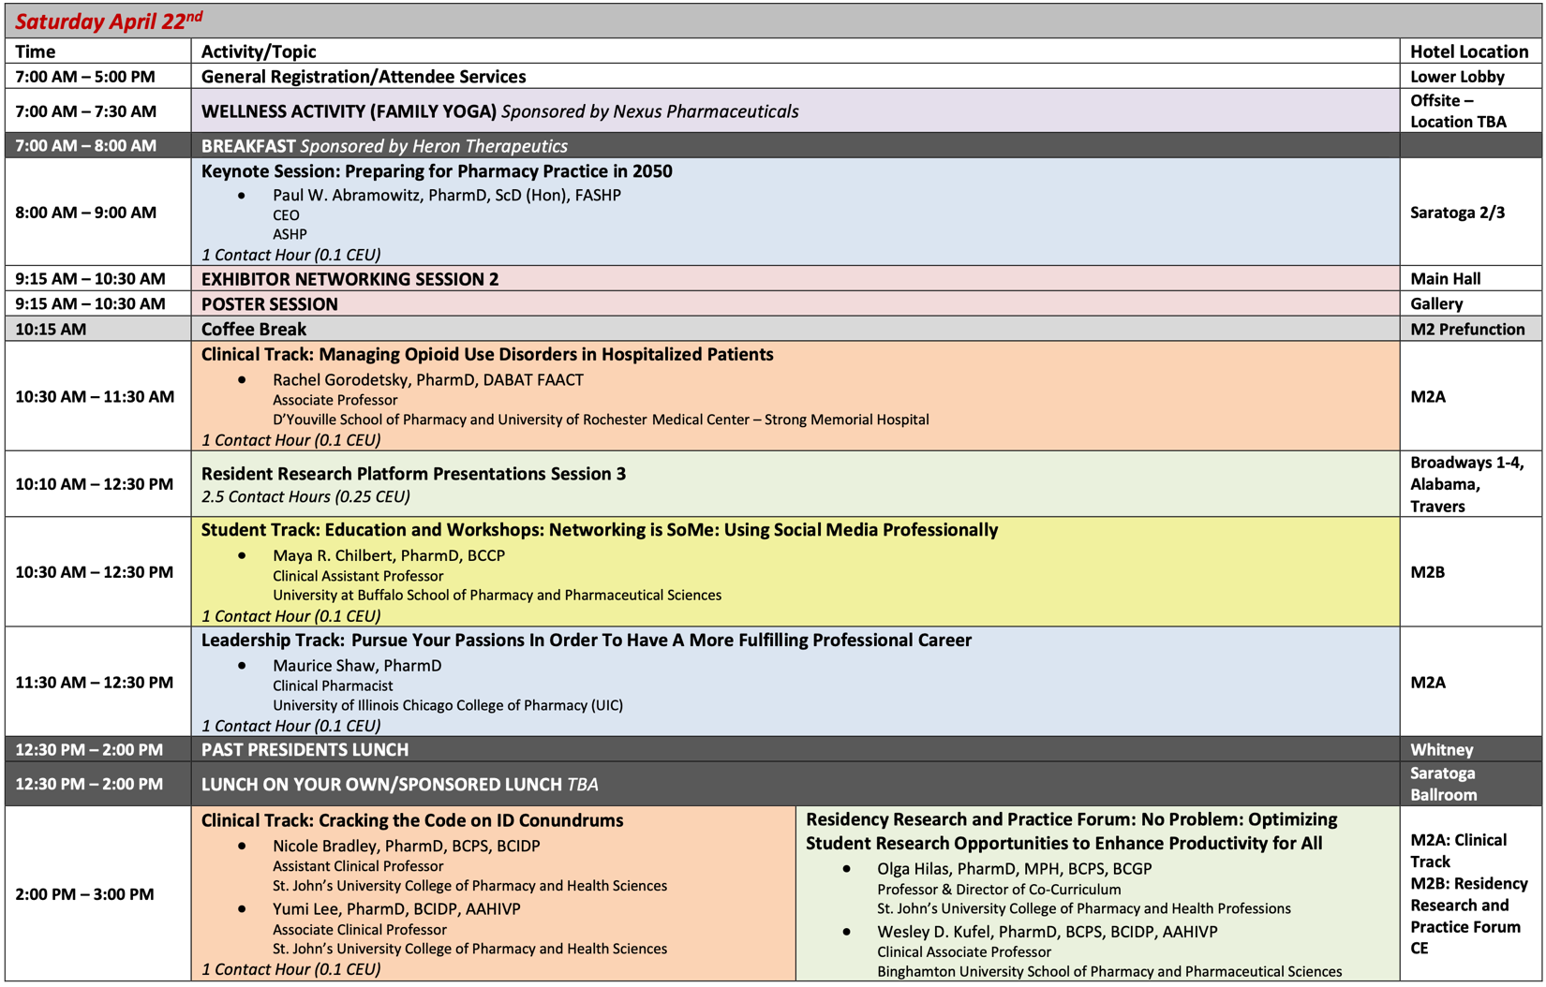
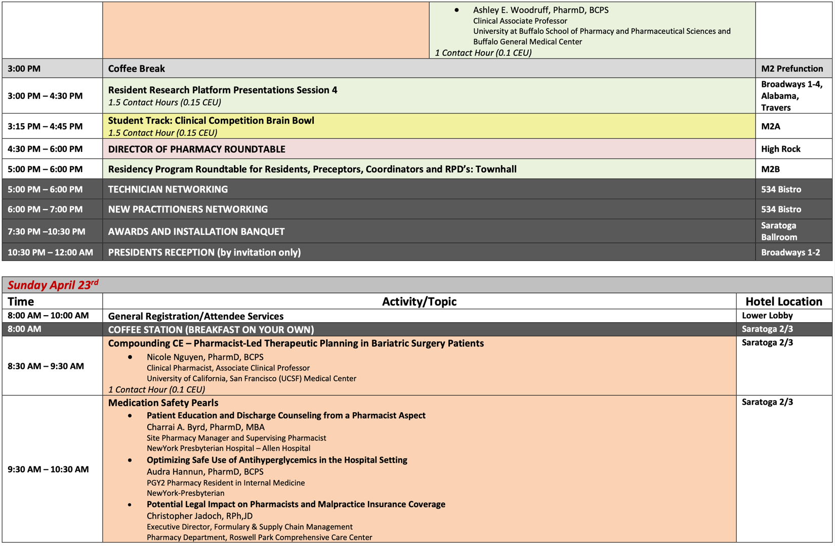
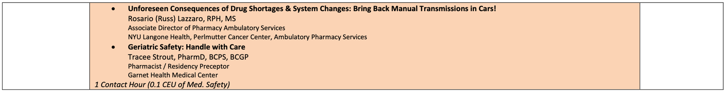

Oncology Symposium 2022
- Attendance: 60
- Vendors: 15 (7 additional waitlisted)
- Venue: NYU Langone
- Educational programming
Time | Speaker(s) | Topic title
Saturday, June 18th, 2022  8:00 AM – 9:00 AM  PHARMACY TIMES |  | PHARMACY TIMES  Chronic Lymphocytic Leukemia: Optimizing Patient Care Through Expert Knowledge of Drug Therapies and Treatment-Related Toxicities
Saturday, June 18th, 2022  9:00 AM – 10:00 AM  ASHP SPEAKER |  | Immunotherapy
Saturday, June 18th, 2022  10:00 AM – 11:00 AM  KEYNOTE | Benyam Muluneh | KEYNOTE: The Next Frontier: Moving from Innovation to Optimization
Saturday, June 18th, 2022  11:00 AM – 12:00 PM  EXHIBITS | EXHIBITS | EXHIBITS
Saturday, June 18th, 2022  12:00 PM – 1:00 PM  PHARMACY TIMES |  | PHARMACY TIMES  Caring for Patients With Multiple Myeloma Through Pharmacist-Directed Supportive Care and Toxicity Management Strategies
Saturday, June 18th, 2022  1:00 PM – 2:00 PM | Stephen Eng  Nicole Daukshus | CAR T-cell Therapies: Current Treatment Strategies in the Adult and Pediatric Population
Saturday, June 18th, 2022  2:00 PM – 3:00 PM | Peter Campbell  Jordan Pleskow | COVID-19 and Cancer: The Current Impact on Treatment and Supportive Care
Saturday, June 18th, 2022  3:00 PM – 4:00 PM  Resident Clinical Pearls | Alice Wang | The ART of Chemotherapy: Navigating Interactions Between Antiretrovirals and Chemotherapy
 | Chandni Patel | Role of Glucarpidase in Delayed Methotrexate Clearance
 | Alyssa Cendagorta | Review of Asparaginase Toxicity and Adult Dose Capping
 | Angelica Bevinetto | Therapeutic Drug Monitoring (TDM) of Asparaginase in the Pediatric Population
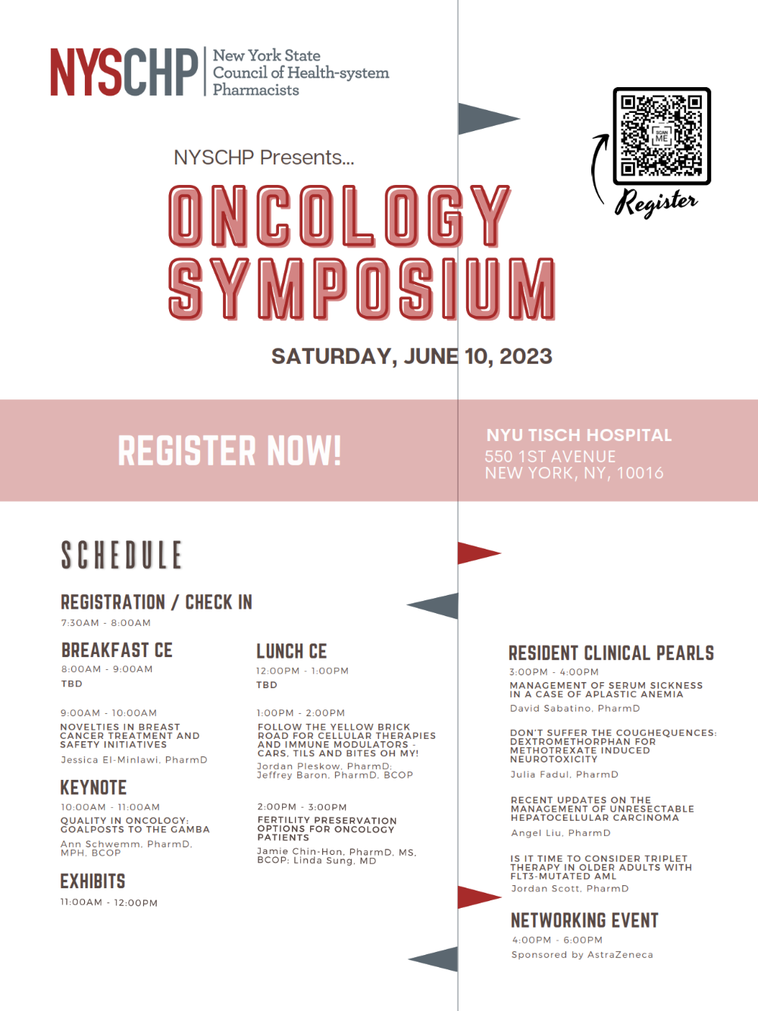
Oncology Symposium 2023 registration open

TriState 2022
- Attendance: 122 attendees including speakers, staff, etc. (up from 88 in 2021)
- Vendors: 38 exhibitors (down from 45 in 2021)
- Future: Board agreed to not continue with TriState in 2023; plan to replace this with smaller events across the state. Oncology symposium has essentially replaced the income.
- Keynote: A Resiliency Strategy for Pharmacy
  - Peter Bolo, MD
- Panel 1: Ending the Readmission Cycle: Pharmacy’s Role in Transitions of Care
Panelists:
  - Jessi Bootle, PharmD, BCACP, BCPS
  - Hansik Kim PharmD, BCPS, BCCCP
  - Michael Nabiyev, PharmD
  - Hinal Patel, PharmD, BCPS
  - Crystal Toribio, PharmD
- Panel 2: Technology Insight: The Many Roads to an Opioids Dashboard
Panelists:
  - Kim Walker
  - Rakesha Babu
  - Edward Dix
- Panel 3: Hospital at Home: The Future of Inpatient Care?
Panelists:
  - Ania Wajnberg
  - David Goffman
  - Michele Amundson

TriState 2024: Replacement director forum with CE and exchibit for 2023. 2024 planning underway.

Geriatrics Certificate 2022-2024
- Registration open: https://nyschp.memberclicks.net/index.php?option=com_mcform&view=ngforms&id=2114150
- 133 registered as of January 10, 2023
  - 17 have received the certicate thus far
- https://nyschp.memberclicks.net/geriatric-certificate-program

Activities: Future

Date | Time | Day of Week | Title | Program at Which Program was Held | Speaker(s) | Chapter Webinar is Originally From | Chapter that Speaker is a Member of
3/16/2023 | 6-8 PM | Thurs | NYSCHP: 2023 DEI Webinar Series - Session 1 | Miniseries | Troy Lynn Lewis, Katie Cardone | Original | Non-mem
3/21/2023 | 6-8 PM | Tues | NYSCHP: 2023 DEI Webinar Series - Session 2 | Miniseries | Rebecca Chu, Lisa Yamagishi, Amber Johnson | Original | NYC
April | Annual Assembly | All Day | - | Annual Assembly | - | Original | -
5/16/2023 | 7-8 PM | Tues | Drug Approvals Update – Focus on 2022 | Monthly Webinar | Elizabeth Shlom | Original | Westchester
6/10/2023 | Oncology Symposium | All Day |  |  |  | Original
August |  |  | NYSCHP: 2023 Compounding Webinar Series - Session 1 | Miniseries |  | Original
August |  |  | NYSCHP: 2023 Compounding Webinar Series - Session 2 | Miniseries |  | Original

Other Future Plans:
- Replacement of local webinar reaccreditation with original content to meet certificate programs
- Future certificate programs:
  - Diversity certificate program
  - Leadership certificate program

- Strategic Plan Tasks: Status Update
- Engage

Strategy | Action Items | Notes
Develop innovative and attractive programming and networking opportunities for all members. | Subcommittee meetings for webinar, Tristate and Annual Assembly programming, specialty symposia, certificate programs | Work with associated directors and committee chairs
Continue surveying members & potential members to identify needs, trends, and effectiveness of current offerings. | Annual membership education interest surveys  Technician education interest surveys  Student education interest surveys  Annual Assembly education survey | Work with associated directors and committee chairs
Increase greater awareness and participation in NYSCHP programming. | Regular email blasts and social media calendar review.  Plan in future to synchronize Podcasts, YouTube Channel, Webinar CE if possible | Work with Communication Committee

- Lead

Strategy | Action Items | Notes
Design and implement annual leadership development cycle, including recruitment, orientation, and key governance documents and resources. | Annual call for program chairs/subcommittee chairs in the summer conducted and selections made.
Continue to develop Committees, ensuring structure and goals meet Council’s needs. | Subcommittee reports at quarterly meetings

- Advocate

Strategy | Action Items | Notes
Provide routine reporting methodology for all government affairs issues and updates. | Advocacy CE | Work with Director of Advocacy and associated committees
Increase interest and participation in Lobby Day. | Advocacy CE

- HOD Recommendations: Status Update

- “Recommend certificate programs around leadership development”: Working with leadership committee on this offering for the past year or so. Discussed in detail at January EPD committee meeting.
- “Recommend selling CE programs, certificate programs to other health-system organizations”: Discussed in detail at January EPD committee meeting. Several ideas were brought up on how to leverage this. Miniseries and select CE are already available for purchase for non-members. Will attempt to leverage future certificate programs such as leadserhip or DEI to provide content that is more static and able to be delivered by a select group of faculty.

- Review of Position Statements: Status Update
None at this time

Respectfully submitted,

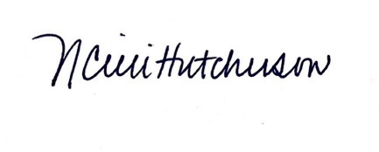
Nicole Cieri-Hutcherson, PharmD, BCPS, NCMP
Director, Education and Professional Development

