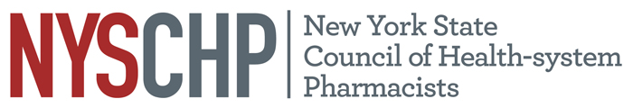
230 Washington Ave Extension, Albany NY 12203 - 518-456-8819

2023 HOUSE OF DELEGATES

Saratoga City Center, Saratoga Springs NY

April 20, 2023

REPORT OF THE EXECUTIVE DIRECTOR

Shaun C. Flynn

This report is for consideration by the New York State Council of Health-system Pharmacists House of Delegates only and does not represent official policy until approved the House of Delegates.

- Responsibilities of the Executive Director

The Executive Director shall be responsible for the administrative activities of NYSCHP including direction of all operations, programs and activities. The Executive Director shall at all times, support the vision, mission and goals of NYSCHP.

- Operations

  - Administration
      - The 2024 Annual Assembly will be held on April 18 through April 21, at the Saratoga Hilton, Saratoga Springs, NY.
      - The Council is preparing to host two in person Director of Pharmacy Roundtables this fall.
      - The Council will be holding its second annual Oncology program June 10.
      - NYSCHP continues to provide administrative support for the New York State Council of Health-system Pharmacists Research and Education Foundation (REF) and assists in the administration of the REF awards.
      - The Executive Director has onboarded a new contract lobbyist for the Council. The Executive Director will continue to serve as a lobbyist in conjunction with Rebecca Miller from CHMS. Advocacy efforts have focused on 340-B, technician supervision, CDTM, CLIA waived testing, and white bagging legislation.
      - This year the Council was able to restore some of the budget cuts that were made during the pandemic, but some financial measures remain in place to help the organization deal with high inflation while rebuilding reserves. Through maintaining some budget cuts, a long-term fixed rate contract with CHMS and long-term staff give backs, the Council was able to either mitigate or avoid the worst impacts of high inflation this year with little impact on initiatives. The Council’s 2021-2022 budget is $662,900 with the biggest increases over last year coming from the Annual Assembly, lobbying contract and the return to in person ASHP meetings. Administrative cost increases remain well below inflation with the CHMS contract increasing at 3% per year while staff costs are 8% lower than 2014 in inflation adjusted dollars While this was a significant improvement in the budget from the peak of the pandemic, the Council budget is 36% lower than 2014 in inflation adjusted dollars. As a result of this, the Council was only able to restore partial funding for a lobbyist, with the Executive Director maintaining significant responsibilities for that area. Certain austerity measures will have to remain in place for the foreseeable future to meet our financial reserve goals, posing significant operational challenges. The BOD will discuss the plan for paying off the $150,000 Small Business Administration loan this Summer.
      - Social media activity for the Council continues to grow with an enhanced focus on Instagram and You Tube. As a result of these efforts, we continue to increase our followers on all of the Council’s accounts.

- Activities

Nationally: I have represented NYSCHP at the following ASHP events: the 2022 Midyear Clinical Meeting, 2022 Presidential Officers Retreat in Dallas, ASHP Legislative Calls and the ASHP state affiliates meetings.

State: On the state level, I have attended meetings with the Alliance of New York Licensed Health Professionals (ANYLHP), IPRO, Empire State Society of Association Executives (ESSAE), NYS Pharmacy Conference, NYS Senate, NYS Assembly, NYS Office of the Professions, the State Education Department, State Department of Health, Bureau of Narcotic Enforcement and NYS Board of Pharmacy. NYSCHP continues to work collaboratively with PSSNY, the Chain Pharmacy Association and ASCP to promote our mutual legislative agendas. I will continue to work to expand the Council’s visibility in these areas and pursue avenues for NYSCHP to provide input with regard to professional and legislative issues that promote and enhance the pharmacy profession. The Council has also expanded our work with the hospital associations on issues such as 340-B, white bagging and technician supervision.

Respectfully submitted,

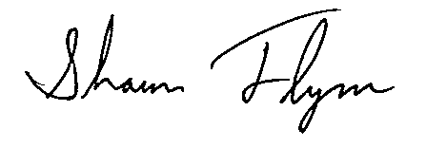
Shaun C. Flynn
Executive Director

