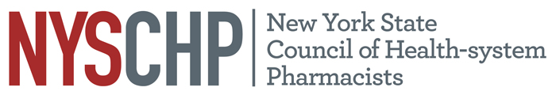
230 Washington Ave Extension, Albany NY 12203 - 518-456-8819

November 2023 Virtual House of Delegates
AGENDA

Order of Business
November 29th, 2023
6:00 PM - 8:00 PM

1. Call to Order
2. Greetings
3. Roll call of the delegates
4. Position statement review
5. Unfinished Business
6. New Business
7. Announcements
8. Adjournment

