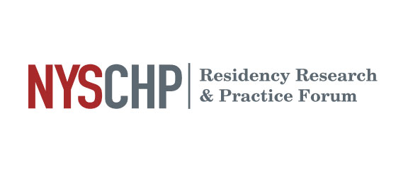

Presentation Information for Residents

- Please arrive 5-10 minutes before the start of the session in which you have been scheduled to present and locate the moderator so you can put your presentation on the designated laptop.
  - Please bring presentation on a portable USB thumb drive.
  - Schedule will be available no later than March 15th, 2024

- Presentation requirements:
  - All platform presentations should be in Microsoft PowerPoint. Apple Keynote functionality will NOT be accepted, all presentations MUST be formatted in Microsoft PowerPoint and PC compatible
    - Please do not rely on “Presenter View” as we cannot guarantee that it will be available.
    - No MAC computers will be available so all presentations MUST be PC compatible.

  - Slide 2 of the presentation must contain acknowledgement of conflicts stating none if there are none.

  - Platform presentations are allocated in 20 minute increments
    - Each presentation must be completed in 15 minutes
      - 12 minutes for the presentation
      - 3 minutes for questions
    - The remaining 5 minutes allows for the changing of speakers and for the evaluator to meet with the resident to review their presentation evaluations.

  - Suggested presentation format/sections to include
    - Disclosures/Conflict of interests (see above, must be included)
    - Background
    - Objectives
    - Methods/Study Design
    - Results including Data/Statistical Analysis
    - Discussion/Conclusions
      - Including discussion of strengths and limitations

  - Your assessment question does NOT need to be included in the presentation

- Residents will receive feedback from an assigned evaluator immediately following their session. All evaluations will be collected on paper and distributed to the resident at the conclusion of their presentation.

- Residents and preceptors are strongly encouraged to attend all presentation sessions, participate and complete an evaluation for each presentation.

- Research Awards will be determined by the organizing committee for the top Residency Program presenters in PGY1 or PGY2 categories. Awards will be conferred at the Annual Assembly Awards & Installation Banquet Saturday, April 20, 2024.

