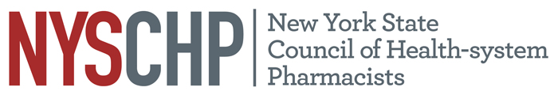
230 Washington Ave Extension, Albany NY 12203 - 518-456-8819

TO: Delegates, Alternate Delegates and Past Presidents
2024 House of Delegates
FROM: Stephanie Seyse, Chair, House of Delegates
Angela Cheng-Lai, Chair, Resolutions Committee
SUBJECT: Notice of Resolutions Committee Conference Call (virtual)

The Resolutions Committee will meet via conference call on April 11, 2024 from 3-5 pm. To participate in this conference you will be given a Zoom link. Please let the Resolutions Committee Chair, Angela Cheng-Lai (ACHENG@montefiore.org), know who from your chapter will be the representative so you can see the items being discussed. This conference call will take the place one week prior to the NYSCHP Open Hearing and the NYSCHP House of Delegates.

According to the Regulations of the House of Delegates: The Committee on Resolutions shall consist of a Chairperson, one representative from each Affiliated Chapter and Technician and Student delegation. The Committee shall be responsible for drafting statements in resolution form which shall reflect the official policy of the Council and for reviewing resolutions submitted to it from the Affiliated Chapters and from individual members of the Council. The report of the Committee on Resolutions shall be presented to the House of Delegates.

If you have any questions, please feel free to contact the Council Office at (518) 456-8819.
Thank you.

