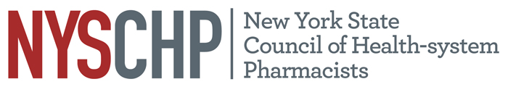
230 Washington Ave Extension, Albany NY 12203 - 518-456-8819

2024 HOUSE OF DELEGATES

Saratoga City Center, Saratoga Springs NY

April 18, 2024

REPORT OF THE EXECUTIVE DIRECTOR

Shaun C. Flynn

This report is for consideration by the New York State Council of Health-system Pharmacists House of Delegates only and does not represent official policy of the House of Delegates.

- Responsibilities of the Executive Director

The Executive Director shall be responsible for the administrative activities of NYSCHP including direction of all operations, programs and activities. The Executive Director shall at all times, support the vision, mission and goals of NYSCHP.

- Operations

  - Administration
      - The 2025 Annual Assembly will be held on April 3 through April 6, at the Saratoga Hilton, Saratoga Springs, NY.
      - The Council is preparing to host two in person Director of Pharmacy Roundtables this fall.
      - The Council will be holding its second annual Oncology program June 8.
      - NYSCHP continues to provide administrative support for the New York State Council of Health-system Pharmacists Research and Education Foundation (REF) and assists in the administration of the REF awards.
      - The Executive Director continues to serve as a lobbyist in conjunction with Rebecca Miller from CHMS. Advocacy efforts have focused on 340-B, technician law expansion, CDTM, CLIA waived testing, test and treat, and central fill legislation.
      - This year the Council was able to restore the remaining budget cuts that were made during the pandemic and make significant contributions to our financial reserves. The Council’s budget remains 22% lower than its height in 2014, but that gap has closed by 3% since 2019. The Council was able to contribute $200,000 to reserves this year, bringing us to about 78% of our goal. The Council will need to save about $250,000 over the next six years to meet the goal of having one years’ worth of expenses in reserves by the end of the decade. In light of the significant progress made in rebuilding our financial reserves, the BOD will discuss the plan for paying off the $150,000 Small Business Administration loan at the end of the year.
      - This year the Council launched monthly calls for our Clinical Directors and Managers. The Council also held our first mid-year meetings of the Directors of Pharmacy and the Clinical Directors and Managers at Touro College of Pharmacy.

- Activities

Nationally: I have represented NYSCHP at the following ASHP events: the 2023 Midyear Clinical Meeting in Anaheim, 2023 Presidential Officers Retreat in Dallas, ASHP Legislative Calls and the ASHP state affiliates meetings. I also continue to serve on the PTCB Stakeholder Advisory Committee which met in June in Chicago.

State: On the state level, I have attended meetings with the Alliance of New York Licensed Health Professionals (ANYLHP), IPRO, Empire State Society of Association Executives (ESSAE), NYS Pharmacy Conference, NYS Senate, NYS Assembly, NYS Office of the Professions, the State Education Department, State Department of Health, Bureau of Narcotic Enforcement and NYS Board of Pharmacy. NYSCHP continues to work collaboratively with PSSNY, the Chain Pharmacy Association and ASCP to promote our mutual legislative agendas. I will continue to work to expand the Council’s visibility in these areas and pursue avenues for NYSCHP to provide input with regard to professional and legislative issues that promote and enhance the pharmacy profession. The Council continues to work with the hospital associations on issues of common interest and is now also working with SEIU 1199 on common issues as well.

Respectfully submitted,

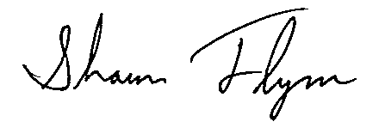
Shaun C. Flynn
Executive Director

