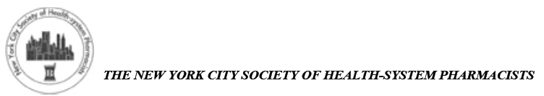
Presentation: Fundamentals of Hematopoietic Stem Cell Transplantation
_____________________________________________________________________________________________
Date: 1/12/17

6:00-6:30 PM Registration
6:30 PM Announcements & Dinner
7:00 PM CE Presentation: Fundamentals of Hematopoietic Stem Cell Transplantation by Maxwell Brown, PharmD, Clinical Pharmacy Manager of Stem Cell Transplant
NewYork-Presbyterian Hospital/Weill Cornell Medical Center

8:00 PM CE Program Ends
8:30 PM Dinner Ends

Location: Club A Steakhouse
240 East 58th St
New York, NY 10022
_________________________________________________________________________________________
CE Presentation Objectives:
Pharmacist Learning Objectives:
- Provide an overview of hematopoietic stem cell transplant (HSCT)
- Identify indications of autologous and allogeneic HSCT in patients with hematologic malignancies, non-malignant hematologic disorders, and select solid tumors
- Review the features and management of significant toxicities associated with conditioning chemotherapy and immunosuppressive therapies used in HSCT
- Discuss post transplant complications

Technician Learning Objectives:
- Describe an overview of the hematopoietic stem cell transplant (HSCT) process
- Explain which patients with cancer receive a transplant
- Discuss side effects of chemotherapy and immunosuppressive medications used in the HSCT setting
- Review complications that occur after transplant

Continuing Education Accredited By: New York State Council of Health-system Pharmacists
Intended audience: Pharmacists, Pharmacy Technicians

The NYS Council of Health-system Pharmacists is accredited by the Accreditation Council for Pharmacy Education as a provider of continuing pharmaceutical education. This program () will be accredited for 0.1 CEU’s (1 contact hour). Statements of Continuing Pharmaceutical Education

This is a knowledge based program.
_____________________________________________________________________________________
A $10 non-refundable fee for members is due at the time of registration. A $65.00 non-refundable fee for non-members is due at the time of registration. RSVP early as seating may be limited. RSVP via email. RSVP no later than January 12th, 2017 to: Karen Berger, President-Elect (preferred): nycshp@gmail.com with “Janmeeting” as subject heading. Please include the following information: Name, phone/email, affiliation/college, NYCSHP member (yes, no), Student (yes, no).
_______________________________________________________________________________________

