The Rochester Area Society of Health-System Pharmacists

2 Credit Hour Dinner CE Program with
A Panel Discussion featuring Health-System Leaders
_________________________________________________________________

Business of Healthcare and
What to do When the CFO Wants You to Cut your Budget
Todd Nelson, MBA
Vice President of Education and Organizational Solutions
Healthcare Financial Management Association (HFMA)

Wednesday January 18th, 2017
5:00 pm Registration
5:30 pm Dinner
6:00 pm – 8:00 pm Program

Location:
St. John Fisher College
Integrated Science and Health Science Building
Room 117
3690 East Ave
Rochester, NY 14618

___________________________________________________________________

Objectives

- Define the impact of payment reform on hospitals and health systems
- Evaluate different payment methodologies for healthcare reimbursement
- Identify challenges with alternative payment models
- Define the multiple factors driving cost increases in healthcare
- Formulate a strategy for dealing with cost reduction initiatives in health systems
- Evaluate cost reduction strategies for effectiveness and sustainability
- Identify potential impacts on patient care of cost reduction strategies and minimize them

How to Register:
- Please use your PayPal account through our website at www.rashp.org to pay and register for the event. If you have any questions please email Alexandra.Fuller@Thompsonhealth.org. Reservations must be made by Monday January 16th 2017
- Reservations received after the above date are limited to availability, please contact Alexandra Fuller.
- If you register for the meeting, but cannot attend, please notify RASHP ASAP to avoid chapter charges.
- Please note that all attendees will have 45 days from the date of the program to process their CE.

Fees:
- RASHP Member, WSOP Faculty, WSOP Preceptors, PSR Member ($40)
- WSOP Student members and technicians ($20)
- Non-RASHP member healthcare professional requesting CE ($200)

This program is appropriate for pharmacists, technicians, nurses, physicians, dentists and other health care professionals. This program is a knowledge-based continuing professional education activity (CPE) where pharmacists and technicians acquire factual knowledge based on evidence as accepted in the literature by health care professions. This program is sponsored by RASHP.

The NYS Council of Health-system Pharmacists is accredited by the Accreditation Council for Pharmacy Education as a provider of continuing pharmacy education. These programs (0134-0000-15-170-L01-P, 0134-0000-15-172-L01-P, 0134-0000-15-0171-L01-T, 0134-0000-15-172-L01-T) are approved for 0.2 CEU’s (2 contact hours). Statements of Continuing Pharmacy Education Credit are available by survey links given after the program. Participant must verify attendance at the meeting by entering the program CE code. Attendees have forty five (45) days to evaluate the program and obtain their statements of credit
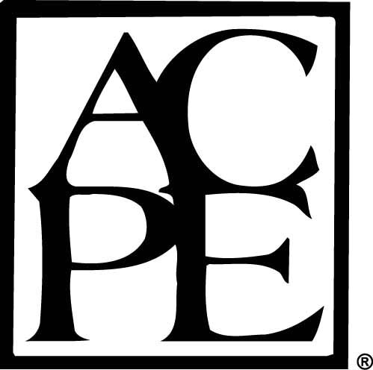

Payments to NYSCHP are not deductible as charitable contributions for federal income tax purposes. However, they may
be deductible under other provisions of the Internal Revenue Code (i.e., ordinary, necessary business expenses;
miscellaneous itemized deduction).

