Western New York Society of Health-System Pharmacists
Board of Directors Meeting Minutes
Tuesday, May 10th, 2022
UB College & Zoom

In attendance: Aubrey Defayette, Kristen Fodero, Megan Zach, Jaclyn Healy, Kelsey Gregiore, Nicole Cieri-Hutchinson, Collin Clark, Laura Wilkinson, Michelle Falcone, Kristen Cirbus, Deidre Skalla, Haley Martynowicz, Nicholas Nawrocki, Rabeya, Emma Studlack, Patrick McGrath, Aleah Groman, Courtney Jarka, Stephanie Flint, Dominick Harris, Jocelyn Furer
Not present: Lindsey Feuz, Bill Prescott, Tim Hutcherson, Talissa Marchese, Mike Milazzo, and Stephanie Seyse

- Call to Order & Approval of Previous Meeting Minutes
  - Motion – Kelsey
  - Second – Kristen

- President’s Report (Defayette):
- NYSCHP updates:
  - Oncology Symposium
    - Saturday, June 18th; 7:30am – 4pm; NYU Tisch Hospital
  - NYSCHP Webinar Programs:
    - Pharmacist’s Role in Transgender and Gender Non-conforming Care, Thursday, June 2nd @ 12pm
      - Anthony Gerber, Pharm D NYCHP Health + Hospitals / Coney Island
    - Call for speakers – August General Medicine Miniseries
      - Nomination and self-nominations welcome and due by Sunday, May 15th - 1 hour presentation ($200/hr honorarium)
  - Royals Counties NYC Regional Pharmacy Residency Conference
    - Friday, June 17th from 8:30am to 4pm; $10 to attend for pharmacists/residents and free for students
  - Nicole - Annual Assembly wrap up
    - Highest attendance in history – 552 attendees
    - Survey will be coming
    - First meeting with new board – Friday, May 13th
  - Nicole - Geriatric programming
    - Some home study material coming
    - Can still sign up if interested
- WNYSHP updates:
  - C&B – approved
  - Financial responsibility and conflict of interest form
    - Due again in 2024 but will try to look at them sooner
  - Strategic plan
    - Forms
      - Aubrey attended for the council; she met with Lindsey and Jacky
      - Recommended financial responsibility and conflict of interest form for when each person becomes a member
    - Strategic plan for chapter
      - Goals and budget

  - 2021 – 2022 Updates and Plans
    - Postponed Friends of Night People Volunteer event in May - Will try to reschedule for August
      - Awards and Installation Banquet: Angela (current President) and Bob (President elect) coming
    - BOD meeting
      - June 14 5:30-6:30 added at D’Youville
      - In person would be most ideal
      - Nicole to make zoom link
    - First Annual Resident Mixer
      - Thursday, July 7th from 4:30 – 6:30pm at Resurgence Fireside Lounge; confirm attendance June 30th
      - Tentative agenda
        - 4:30 – 5pm: People arrive/check-in/snacks provided by WNYSHP/get drinks, 5 – 5:20pm: Ice breakers
          - 5:25 – 6:05 pm: Round tables (5 minutes then switch) – for residents, RPDs, and other pharmacists that are at the event
            - WNYSHP members with NYSCHP board positions (past/present) (Stephanie / Nicole / Tim?)
            - WNYSHP board members
            - Grassroots advocacy committee (Kelsey / Mike?)
      - Residents, RPDs, site champions

- Immediate Past President Report (Fodero):
  - Election results will be sent out soon – winners were notified Monday, May 9th
  - Drum circle
    - $75 up to 50 people for one hour
    - Just need to supply location
      - Aubrey and Kelsey first and second
      - Target August date

- President Elect Report (Healy):
  - Awards committee – winners were notified today

- Secretary’s Report (Zach):
  - Nothing to report

- Treasurer’s Report (Feuz):
  - Annual Assembly Reimbursement
1. Courtney Jarka (Sent – Check 1336)
- Registration: $500
- No Hotel – reimbursement to Laura W.
Total: $500
Mailing Address: 298 Main St. Apt # 1004 Buffalo, NY 14202
2. Collin Clark (Sent – Check 1334)
- Registration: $600
- Hotel Full ($611.64): $305.82
Total: $905.82
Mailing Address: 1329 North Forest Road Apt D12, Williamsville, NY 14221
3. Kristen Fodero (Sent – Check 1337)
- Registration: $520
- Hotel Full ($611.64): $305.82
Total: $825.82
Mailing Address:
4. Jaclyn Healy (Sent – Check # 1333)
- Registration: $520
- Hotel Full ($611.64): $305.82
Total: $825.82
Mailing Address: 62 Palmer Ave, Buffalo, NY, 14217
5. Laura Wilkinson (Sent – Check 1335)
- Registration (early): $395
- Hotel Full (Courtney & Laura): $614.64
Total: $1009.64
Mailing Address: 333 Thorncliff Road Buffalo, NY 14223

March 1st, 2022 | $34,999.34
Deposits/other credits
Square (March CE) | $983.85
Exhibitus, Inc. Sponsor Check -3/21/22 | $1,000
Interest 3/31/22 | $0.30
Total Credits | $1,984.15
Withdrawals/Debits
Check 1327 – Lindsay O, Feb CE Honorarium | -$100
Check 1331 – Rizotto’s Restaurant March CE | -$1463.50
Walgreen – gift cards for CE winners | -$50
Amazon – laptop cover | -$12.71
Tops (Director Forum) | -$27.08
Target (Director Forum) | -$16.48
Spot Coffee (Director Forum) | -$61.98
Square FEES | -$28.83
Total Debits | $1,760.58
March 31st, 2022 Balance | $35,222.91
April 1st, 2022
Deposits/other credits
Square (Webinars) | $18.82
Interest 4/29/22 | $0.29
Total Credits | $19.11
Withdrawals/Debits
Check 1329 – Natalia, CE honorarium | -$100
Check 1330 – Lauren Gressel, CE honorarium | -$100
Check 1332 – NYSCHP Sponsorship for Annual Assembly (donation) | -$500
Check 1334 – Collin Clark Delegate reimbursement | -$905.82
Total Debits | $1605.82
April 30th, 2022 Balance | $33,636.20

Other
- Discussion with Aubrey
  - Formulate a Transition Timeline
  - Aubrey reaching out to NYSCHP for Financial Responsibility and Conflict of Interest – Example
  - Look into Insurance Liability (who is it through)
  - Internal Auditing Committee (Person outside of board member, Maybe a Resident/Delegate combo?)
    - Monthly review by Past President, President, President Elect
  - Plan to send Yearly Budget to Shaun Flynn now prior to submitting to WNYSHP for review
    - NYSCHP said should be figuring out inflation costs into future budgets
  - Need to start thinking about formulating a Strategic Treasury Plan for the Year
- Sent All Reimbursements Checks for Annual Assembly Reimbursement. Sent additional report w/ summary
- Donation to Yoga Parkside – Still need to send $25
- Send to current president, and president elect. (currently have been sending it to Kristen for double check)

- Director of Pharmacy Practice Report (Gregorie):
  - March 22nd live CE dinner at Rizzotto’s
    - Had ~50 people in attendance
  - Acadia lady never emailed me back x3 with confirmation of event ?
  - Pharmacy Times sponsors CE Dinner – May 26th 6-8 pm
    - Creekside Banquets
    - Topic: Anemia on CKD and CLL
    - Free to members – currently 11 signed up (Goal of 20 members)
      - 2 non-members = $30 signed up so far
  - June 16th – Apellis Pharmaceutical Sponsored Dinner
    - Topic: Paroxysmal Nocturnal Hemoglobinuria (non CE)
    - More information to come
  - Awards Banquets – June 21st at 6pm (5-6 pm cocktail hour)
    - Chef’s Restaurant
    - John Armistead from Lee Pharmacy in Florida
    - Topic: Value Added Pharmacy in Post COVID World
    - NYSCHP President will be in attendance (Do we charge? – no )
  - Continuing Education Committee Meeting will be in July to discuss upcoming year
    - Any ideas on presenters or topics please email Kelsey
    - 2021-2022: CE events: September, October, November, February (made virtual) March, May, June (Total ~14 live in-person CE hours available for members)

- Webinar Update (Jarka):
  - Last webinar tomorrow
  - Will be stepping down – laura will help

- Director of Public Policy Report (Milazzo):

- Director of Communication Reports (Marchese):

- NYSCHP Board Liaisons Report (Prescott/Seyse):

- UB Liaison Report (Cieri-Hutcherson): Stephanie Flint
  - Crew neck sale sold 77
  - Ambulatory round table on 4/14 went well
  - Inpatient round table 4/26
  - E-board elections just took place and had dinner

- D’Youville Liaison Report (Studlack): Dominick Harris
  - Semester is wrapping up

- Membership (Studlack):
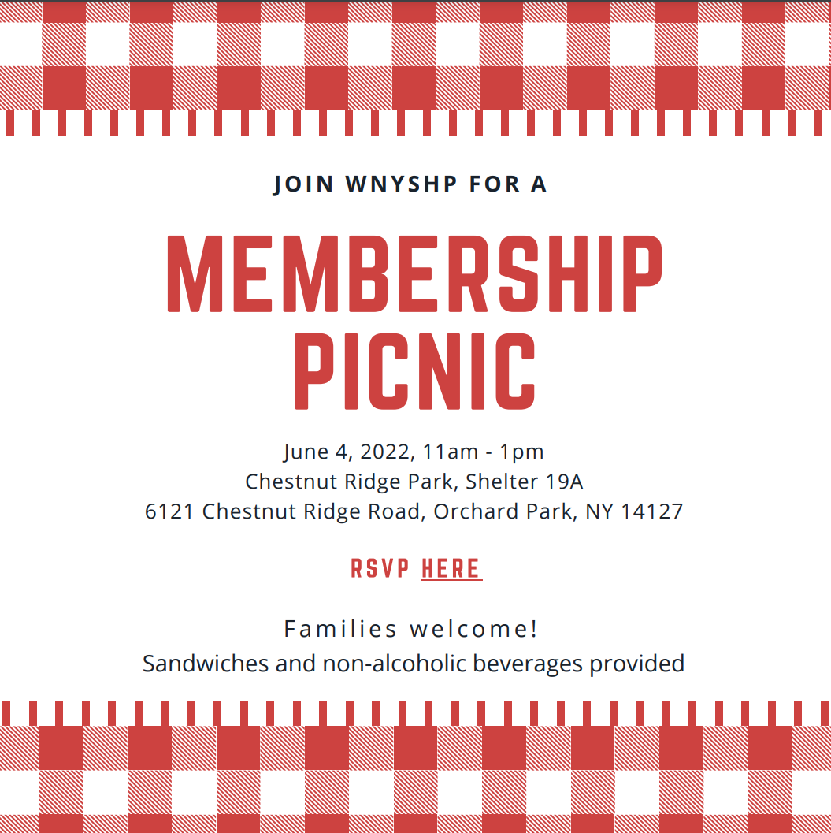

- Please send your communications and update the membership tracking form.
  - Membership tracking form: LINK

 | Active Membership Categories |  |  |  |  | Associate Membership Categories
1st of Month | Phar | Joint | Pledge | Res | Retired | Associate | Faculty | Stud | Tech | Total | Total (Active) | Total (Associate)
October | 68 | 0 | 4 | 34 | 3 | 4 | 3 | 114 | 0 | 230 | 109 | 121
November | 69 | 0 | 6 | 38 | 2 | 4 | 3 | 116 | 0 | 238 | 115 | 123
December | 76 | 0 | 6 | 44 | 3 | 4 | 4 | 163 | 0 | 300 | 129 | 171
January | 67 | 0 | 7 | 37 | 2 | 4 | 3 | 118 | 0 | 238 | 113 | 125
February | 70 | 0 | 6 | 39 | 2 | 2 | 3 | 117 | 0 | 239 | 117 | 122
March | 66 | 0 | 6 | 39 | 3 | 3 | 53 | 117 | 0 | 287 | 114 | 173
April | 72 | 0 | 7 | 37 | 3 | 3 | 55 | 117 | 0 | 294 | 119 | 175
May | 72 | 0 | 8 | 37 | 3 | 3 | 55 | 116 | 0 | 294 | 120 | 174

New Members: March/April
First Name | Last Name | Email
Dimitra | Bitikofer | dekonomi@chsbuffalo.org
Charley | Greenberg | cgreenberg@kaleidahealth.org
Harris | Milanovic | hmilanov@buffalo.edu - student
Parisa | Halaji | parisaha@buffalo.edu – student
Adinoyi | Garba | adinoyig@gmail.com

Renewed Members: February
First Name | Last Name | Email
Stephanie | Hosie | slcarter@buffalo.edu
Talisa | Marchese | marchese@dyc.edu
Brian | Gucwa | brian.gucwa@pfizer.com
Laura | Wilkinson | Wilkil03@dyc.edu
Janice | Alberts | jalberts@kaleidahealth.org
Jaclyn | Healy | healyj61@gmail.com
Brendan | Sorrento | brendan.sorrento@nfmmc.org
Alyssa | Kiel | amnobel@buffalo.edu
Richard | Kraft | richard.kraft@astrazeneca.com
Lindsey | Feuz | lfeuz249@gmail.com
Laura | Volz | volzlm@chsbuffalo.org
Jennifer | Summerville | jlsummerville23@gmail.com

Expiring Members: through April 2022

Active members:
Expiration date | First name | Last name | Email
1/5/2022 | Caroline | Rusch | cerusch@buffalo.edu
1/5/2022 | Christina | Billias | csophiabillias@gmail.com
1/20/2022 | Kristy | DeLuca | kdeluca@seagen.com
1/30/2022 | Kristin | Krajewski | kristin.krajewski@gmail.com
2/8/2022 | William | Jusko | wjjusko@buffalo.edu
2/12/2022 | Frank | Heinrich | wheatfieldguy@hotmail.com
2/18/2022 | Michael | Rudzinski | michaelr@buffalo.edu
3/2/2022 | Cassidy | Luke | cel00575@sjfc.edu
3/11/2022 | Matthew | Calamia | mcalamia01@yahoo.com
3/12/2022 | Daniel | Goupil | coldag@juno.com
3/29/2022 | Jeffrey | Klossner | jmklossn@buffalo.edu
4/4/2022 | Cynthia | Brown | cbrown@kaleidahealth.org
4/14/2022 | Emanuel | Jaffe | ejaffe@buffalo.edu
4/16/2022 | Joseph | Shelley | joseph.shelley@nfmmc.org
5/22/2022 | Kelsey | Gregoire | kviolanti@yahoo.com
6/6/2022 | Lijian | Cai | clj1974@gmail.com
6/26/2022 | Kristen | Kusmierski | kkusmierski@kaleidahealth.org

- Open Forum:
  - No further items presented.

Adjourned at: 6:30

Date | Time | Location
8/10/2021 | 5:30pm | D’Youville & Virtual
9/14/2021 | 5:30pm | UB & Virtual
10/12/2021 | 53:0pm | D’Youville & Virtual
11/9/2021 | 5:30pm | Virtual
1/11/2022 | 5:30pm | UB & Virtual
2/8/2022 | 5:30pm | Virtual
3/8/2022 | 5:30pm | D’Youville & Virtual
5/10/2022 | 5:30pm | UB & Virtual
6/14/2022 | 5:30pm | D’Youville & Virtual

