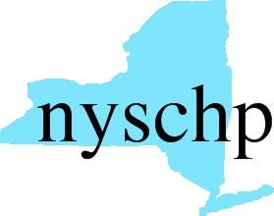 | The New York State Council of Health-system Pharmacists
210 Washington Avenue Extension • Albany, NY 12203
(518) 456-8819 • Fax: (518) 456-9319

2016 House of Delegates
AGENDA

Order of Business
First Session April 28th, 2016 2:00 PM – 4:00 PM

1. Call to Order
2. Greetings
3. Roll call of the delegates
4. Minutes of previous meeting
5. Preliminary report of the Committee on Resolutions
6. Preliminary report of the Committee on Nominations
7. Report of the Vice President, Public Policy
8. Report of the Executive Director
9. Report of the Treasurer
10. Report, Director of Chapter Services
11. Report, Director, Education and Workforce Development
12. Report, Director, Pharmacy Practice
13. Report, Director, Pharmacy Management
14. Report, Director, Industry Affairs
15. Report, Director, Communication Services
16. Recommendations of the Delegates
17. Report of the Committee on Nominations
18. Announcements
19. End of First Session

Order of Business
Second Session April 30th, 2016 2:00 PM – 4:00 PM

1. Call to order
2. Roll call of the delegates
3. Report of the Committee on Resolutions
4. Recommendations of the Delegates
6. Election of Officers
7. Unfinished Business
8. New Business
9. Address of the President
10. Announcements
11. Adjournment

