The New York State Council of Health-system Pharmacists
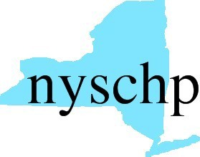

210 Washington Avenue Extension • Albany, NY 12203 (518) 456-8819 • Fax: (518) 456-9319

2016 HOUSE OF DELEGATES

April 28 & April 30, 2016

Delegate Registration Form

Please check one of the following:
1. I will be registering for the Full Program of the 2016 Annual Assembly.
2. I will not be registering for the Full Program of the 2016 Annual Assembly.

CHAPTER NAME:__________________________________________________________
DELEGATE NAME:__________________________________________________________

Please return this form to NYSCHP
Attn: Carol Bizan at cbizan@nyschp.org
March 15, 2016

