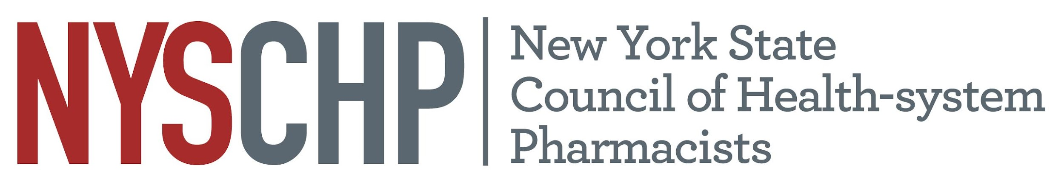

New York State Council of Health-system Pharmacists

The Director of Professional and Leadership Development

David Webster

2/20/26
Rochester, New York

- Responsibility of the Division

The charge of the Division of Professional and Leadership Development, as defined in the Constitution and Bylaws of the NYSCHP, is to be responsible for:
- Development of current and future leaders
- Promote progression of the practice of Pharmacy

- Committees of the Division

Leadership Development Committee

Chair: Kim Zammit
Subcommittees:
Leadership Development Programming – Lead: Paul Green
Succession Planning – Leads: Stephanie Seyse
Leadership Summit Planning (no longer active)

Members:
Brener, Heather
Burczynski, Joe
Cellino, Christ Ange
Chiu, Doreen
Christa Clay
Christensen, Heide
Cieri-Hutcherson,Nicole
Cohen, Henry
Delello, Benard
Dick, Travis B
DiGregorio, Robert
Galla, Ashley
Graber, Laurie
Green, Paul
Lombardi, Tom
Manzo, John;
Pawa, Kenneth
Rodrigues, Daniella
Seeger, Abbie
Seyse, Stephanie
Sinnet, Mark
Tackes, Courtney
Tibi-Scherl, Leila
Voigt, Lisa
Webster, David

Activities: Past
- Leadership Summit in Albany
  - Leadership Development track – targeting current and future leaders to develop skills, share ideas and network
  - Discuss Standard of Care framework and an opportunity for leaders across the profession to coordinate efforts around this practice initiative for NYS, with NYSCHP as a leader
- ASCEND program launch
  - Pairing chapter presidents with established council leaders, providing a framework for mentorship and leadership development
- Leadership Book Club
  - Discussed multiple sources for leadership development in virtual discussions, including topics such as Emotional Intelligence, “Dare to Lead” by Brene Brown, and “Start with Why” by Simon Sinek
- Lunch with a Leader series continuation, including “Women of Influence: A Conversation with ASHP Leaders,” “A Fireside Chat on Advocacy” and “Impact of AI on Pharmacy Practice”
- Annual Assembly planning – coordination of roundtable discussion on AI at the meeting - the focus being on AI tools being used currently and under development (vs. a conversation of what AI is)
- Updated “Job Descriptions” for all Board positions, including desired qualifications, to create more content for future board members to assess their skills and potential for nomination

Activities: Future
- Planning for future Leadership Summit, targeting an every-other year cadence with a focus on ongoing Leadership Develop in the context of Succession Planning for the council, as well as targeting a major practice initiative that would benefit from a network of NYSCHP leaders coming together
- Roll out next phases of ASCEND mentoring program with a focus on succession planning in a broader context of NYSCHP Board leadership
  - Continue with plans to evaluate the first year of the program and results/impact on mentoring and succession planning
- More clearly define roles and responsibilities of Board Positions, committee leadership positions and committee members to broaden the reach to membership and increase engagement
- Continue Leadership Development Book Club with ideas to expand participation
- Continue to develop programming related to Lunch with a Leader, targeting topics as identified in surveys of membership
- Continue to evaluate results of survey to identify future leadership topics and discuss the need for additional surveying to remain current with topics that membership would like covered
- Create a more accessible summary of the board positions descriptions that have been developed by current board members

Virtual Directors Forum Committee

Chair: Bob DiGregorio

Pharmacotherapy leaders – Led by Jess Snead
Directors of Pharmacy – Led by Daryl Schiller
Monthly virtual meetings for both groups

Members:
Open invite to Pharmacotherapy Leaders
Open invite to Directors of Pharmacy

Quarterly Virtual meeting of communities (sub-groups):

- Medication Safety/Informatics (Francesca Sosnowski)
- Technician Leaders (Elon Winston and Christa Clay)
- Entrepreneurial Leaders (Cindy Ipoliti and Heather Brener)
- Pediatrics (Alina Forin)
- Emergency Medicine (Christine Ciaramella and Matthew Poremba)
- Infectious Diseases (Soni Rastagar and Sharon Blum)
- Critical Care (Kelsey Gregorie)
- Ambulatory Care (includes Specialty and Health System Based Community Pharmacies) (Mitchell Miller)​​

Activities: Past
Changed naming to be clearer about targeted groups – “Clinical Directors of Pharmacy” changed to “Pharmacotherapy Leaders” to differentiate from “Directors of Pharmacy” group

Development of programming for two in-person sessions, supporting additional communities based on breakout sessions

Activities: Future

Continue evaluation of communities to best represent the needs of membership

Continue to develop strategies for growing attendance for groups and subgroups, evaluating current invite list and potential to expand reach

Practice Advancement Initiative Committee

Chair: Stephanie Seyse and Joe Burczynski

Members:
Argiro, Stephen
Arya, Amisha
Brener, Heather
Burczynski, Joe
Choi, John
De Urioste, Siobhan
Dick, Travis
Erickson, Karen
Graber, Laurie
Lau, Kwong
Radparvar, Sara
Riebandt, Grazyna
Roman, Rafael
Schiller, Daryl
Seeger, Abbie
Sinnet, Mark
Vink, Timothy
Wang, Shan
Webster, Dave

Activities: Past
- Continued focus on 2 key areas for PAI 2030 – Patient centered care and pharmacy technician roles
  - Continued to add and gather stories from successful programs, highlighting best practices related to medication reconciliation programs
- Continued Webinar Series
  - Technician – “Accredited Technician Training Program”
  - Metrics – “Beyond the Count: Making Pharmacy Metrics Matter”
  - Consolidated Services – “Maximizing Reach: The Strategic Value of Consolidated Pharmacy Services”

Activities: Future
- Standard of Care Task Force – in conjunction with Director of Advocacy and BOD, develop framework and timeline to introduce Standard of Care framework for pharmacy practice in NYS
- Evaluate ongoing changes to PAI initiative to include other components into strategy for this committee, including following the established path of soliciting success stories to share across the council
- A new focus on career advancement for technicians and pharmacists – professional development strategies (vs. antiquated “career ladders”)
- Continue to build on success of webinar series, developing topics based on membership recommendations
- Continue to add resources to the NYSCP website based on webinar topics and best practices identified

- Strategic Plan Tasks: Status Update
- Engage

Strategy | Action Items | Notes
Continue to focus on leadership development for both formal and informal leaders in NYSCHP | Plan additional Leadership Summit targeting 2027 on a biennial basis | Continue focus on leadership development to further engage future leaders in the membership along with highlighting an important practice initiative that can benefit from an in-person session with NYSCHP leaders
Continue and expand Leadership Development opportunities through informal discussion and networking | Continue Leadership Book Club to highlight a diverse list of topics, continue Lunch with a Leader program, continue to identify webinar series topics for PAI | Continue to discuss creative strategies related to expanding the reach of these groups and networking opportunities

- Lead

Strategy | Action Items | Notes
Further develop and build on mentoring program (ASCEND) to continue outreach to future leaders of NYSCHP | ASCEND Program continued rollout to next phase | Incorporate feedback from first year assessment of Chapter Presidents mentoring partnership and continue to expand program

- Advocate

Strategy | Action Items | Notes
Engage NYSCHP Board and Membership in supporting a recommendation for Standard of Care implementation in NYS | Formalize the Standard of Care Framework Task Force and create timeline for introduction/advocacy | This will be a multi-year task force with the initial scope for 2026-2027

- HOD Recommendations: Status Update

Recommendation Assigned | Action Taken (Y/N) or Status Update | If No Action, Indicate Why
N/A

- Review of Position Statements: Status Update

Position Statement Assigned | Status Update | Next Steps as Applicable
The New York State Council of Health System Pharmacists (NYSCHP) supports the utilization of Standard of Care as the regulatory model for pharmacy practice in the state of New York. This includes actively advocating for Standard of Care regulations, and educating pharmacists, educators, other health care professionals, lawmakers, and regulatory bodies on its benefits in reducing health care costs, expanding patient access, and fully utilizing pharmacist training and expertise. | Approved in Virtual HOD January 2026 | Standard of Care Task Force development and oversight

Respectfully submitted,
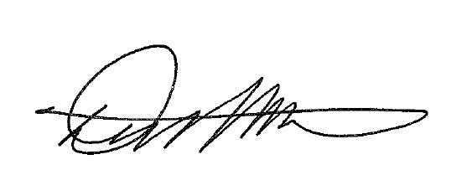
David Webster
Director of Professional and Leadership Development

