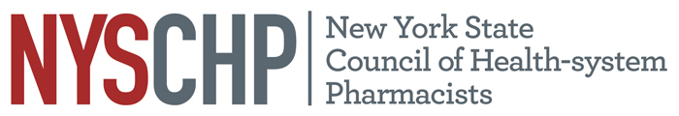
230 Washington Ave Extension, Albany NY 12203 - 518-456-8819

TO: Delegates, Alternate Delegates and Past Presidents
2026 House of Delegates

FROM: John Manzo
Chair, House of Delegates

SUBJECT: Notice of Open Hearing

There will be two Open Hearings in advance of the House of Delegates on April 9, 2026.
- A virtual Open Hearing will take place on Wednesday March 18, 2026 from 6-7 PM.
- A live Open Hearing will take place on Thursday, April 9, 2026 from 11:30 AM to 12:00 PM.

The purpose of the Open Hearings is to provide all Council members with the opportunity to discuss any topic related to health-system pharmacists in New York State, the operation and activities of the NYSCHP, and any appropriate matters for consideration by the NYSCHP House of Delegates and NYSCHP Board of Directors.

All delegates are requested to canvass the membership of your chapter and bring forward matters of concern. In addition, all members should be encouraged to attend and participate in this session.

If you have any questions, please feel free to contact the Council Office at (518) 456-8819.

Thank you.
Open Hearing Agenda
- Greetings and HOD Overview John Manzo, Chair
- Parliamentary Procedure Overview Tom Lombardi, Parliamentarian
- Finance Report Timothy Hutcherson, Treasurer
- Legislative Update Charrai Byrd, Director of Advocacy
- Resolutions Update Travis Dick, Chair Committee on Resolutions
- Membership Update Toshiba Morgan-Joseph, Director of Membership
- Open Forum Delegates and the BOD

