**New Practitioner Spotlight**

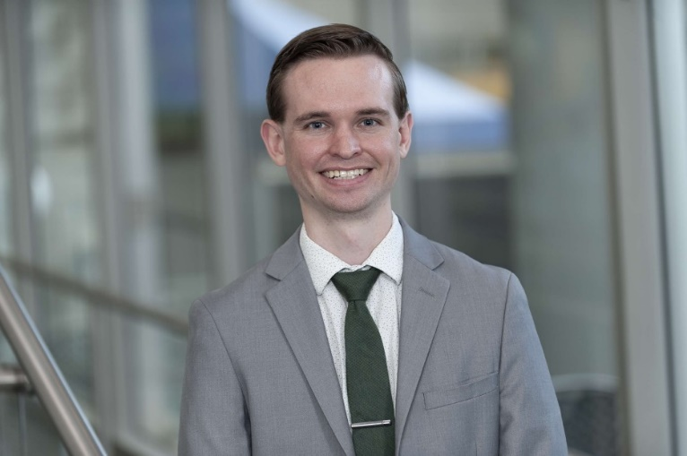

**Logan Moore, PharmD**

**PGY-2 Medication-Use Safety and Policy Pharmacy Resident**

**Memorial Sloan Kettering Cancer Center**

Logan Moore was born and raised in Arizona. He received his B.S. degree in Physiology and Pharm.D. from the University of Arizona. He then completed his PGY-1 Pharmacy Practice Residency at the Phoenix VA Health Care System and is currently a PGY-2 Medication-Use Safety and Policy (MUSP) Pharmacy Resident at Memorial Sloan Kettering Cancer Center. His professional interests include medication safety, formulary management, and pharmacy regulatory compliance. Some of his favorite hobbies include fishing, reading (Sci-Fi), and enjoying sporting events. He is looking forward to getting involved this year with NYSCHP and the New Practitioner Committee!