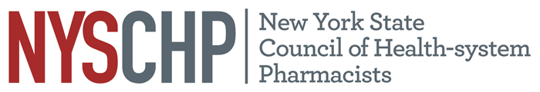
230 Washington Avenue Extension • Albany, NY 12203
(518) 456-8819 • Fax: (518) 456-9319

Talking Points
S1913 - Prescription Drug Anti-Discrimination Act
- The 340B Drug Pricing Program was established by Congress in 1992 to provide significant discounts on prescription drugs to safety net hospitals, community health centers, and other eligible entities serving low-income and underserved patients. These savings enable providers to reinvest in patient care services, expand access to essential medications, and support the financial sustainability of institutions that rely on the program.

- Recent efforts by pharmaceutical manufacturers and pharmacy benefit managers (PBMs) have placed undue restrictions on 340B providers, limiting their ability to fully utilize the program.

- S.1913 seeks to prevent discriminatory practices that undermine the 340B program by:
- Prohibiting restrictions on the use of contract pharmacies, which are vital to ensuring that patients, particularly in rural and underserved areas, can access affordable medications.
- Eliminating excessive administrative burdens, such as requiring unnecessary claim tracking and data disclosures that make compliance difficult for providers.
- Blocking efforts to impose unfair payment conditions, such as withholding 340B discounts or requiring rebates instead of upfront discounts, which negatively impact the financial stability of hospitals and health centers.
- This Legislation is Critical for the following reasons:
- Protects Patient Access: By preventing manufacturers and PBMs from restricting 340B drug discounts, S.1913 ensures that patients who rely on safety net providers continue to receive necessary medications at reduced costs.
- Supports Safety Net Providers: The 340B program allows hospitals and health centers to stretch scarce resources, reinvest in essential health services, and mitigate the effects of government underfunding.
- Follows National Precedents: More than two dozen states have enacted similar laws to prevent discriminatory practices against 340B-covered entities. New York must act now to protect its healthcare providers.
- No Cost to the State: This legislation imposes no financial burden on New York State while offering immense benefits to communities and healthcare providers.
- The NYSCHP stands in strong support of S.1913 and urges swift legislative action to pass this bill. Protecting the 340B program is vital to maintaining access to affordable medications, supporting our safety net hospitals, and ensuring that New Yorkers receive the care they need without undue financial hardship.

