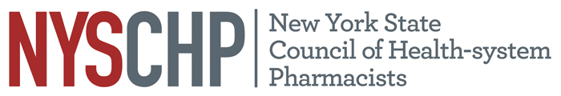
230 Washington Avenue Extension • Albany, NY 12203
(518) 456-8819 • Fax: (518) 456-9319

Talking Points
A1321 -CDTM
• Background of Legislation (2011):
- In 2011, New York State established the Collaborative Drug Therapy Management (CDTM) Demonstration Program.
- The program allows pharmacists, in collaboration with physicians, to adjust, manage, evaluate, and implement drug therapies for patients in specific settings.
- Initially, the program applied only to teaching hospitals and affiliated outpatient and freestanding clinics.
• Successful Implementation and Positive Feedback:
- Preliminary reports indicate that the program has been successfully implemented in eligible facilities.
- Collaboration between pharmacists and physicians has been beneficial in promoting optimal patient care.
• Proposed Expansion in New Bill:
- The new bill seeks to extend the program to all Article 28 licensed healthcare facilities, including hospitals, clinics, and residential health care facilities.
- It also allows CDTM to be practiced in certain community-based settings.
- Nurse practitioners would also be allowed to engage in collaborative agreements with pharmacists.
• Addressing Medication Errors and Adverse Drug Reactions (ADRs):
- ADRs are one of the leading causes of death in the U.S., and medication errors contribute significantly to these events.
- A recent study showed 2.7 million medication errors annually in U.S. hospitals, affecting 130,000 patients, with at least 28% of these being preventable.
- Medication errors result in additional healthcare costs, up to $177 billion annually, with 70% of these costs attributed to unnecessary hospital admissions or extended stays due to errors.
• Effectiveness of Collaborative Drug Therapy Management (CDTM):
- Many other states already permit CDTM, with broader authorization than in New York.
- Research shows that CDTM, along with pharmacist-led services like drug information, ADR monitoring, and participation in medical rounds, significantly reduces medication errors.
• Why the Expansion is Needed:
- The proposed expansion of the program is warranted based on the demonstrated success of the current initiative.
- Expanding the program to more healthcare settings and including Nurse Practitioners as collaborators will further reduce medication errors and improve patient outcomes.
• Conclusion:
- The expansion of CDTM is a logical step to improve patient safety, reduce healthcare costs, and enhance the overall quality of care.
- The collaboration between pharmacists, physicians, and nurse practitioners is crucial to achieving these goals.
- This legislation recognizes the valuable contributions of pharmacy technicians and allows them to play a greater role in patient care and pharmacy operations.

